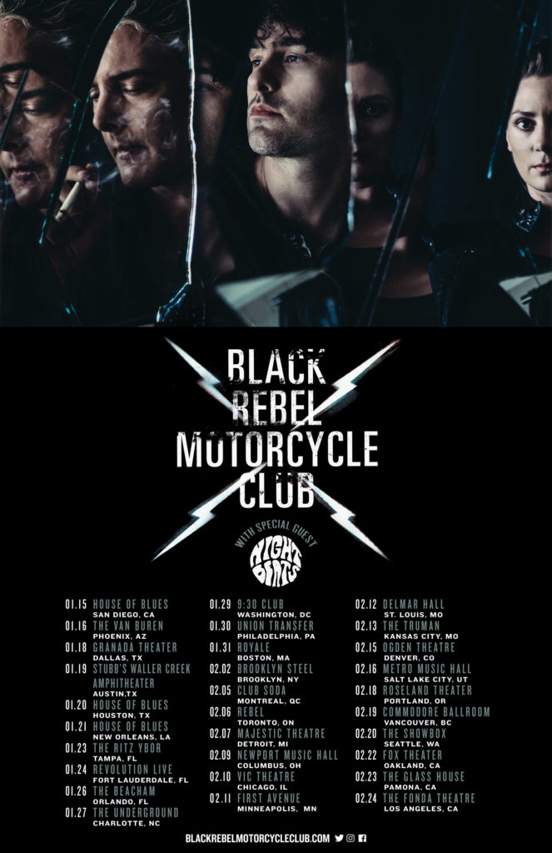

San Francisco based rockers Black Rebel Motorcycle Club invade the Ritz Ybor on Saturday, January 23, 2018 with special guests Night Beats, a Seattle based psychedelic/garage rock band. Black Rebel Motorcycle Club is touring in support of their eighth studio album “Wrong Creatures”, releasing through Vagrant Records on January 12th.
Black Rebel Motorcycle Club - Beat The Devil's Tattoo
Night Beats - Sonic Bloom

Black Rebel Motorcycle Club with special guest Night Beats
Ritz Ybor, Tampa, FL – January 21, 2018 - $23.50 + fees
Tickets available here
Avoid Ticketmaster fees and pick up tickets at Daddy Kool Records
666 Central Avenue North, St. Petersburg, FL 33701
map

