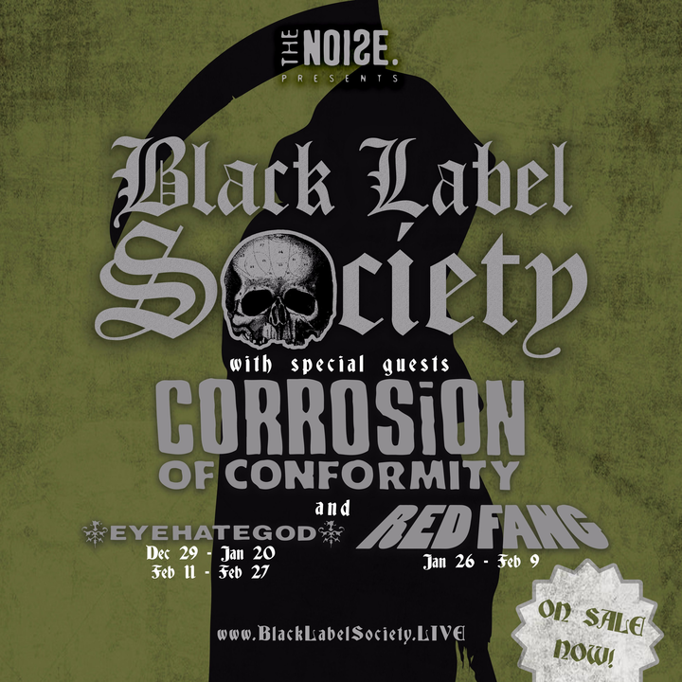

Black Label Society is coming to Jannus Live on January 26, 2018 with special guests Corrosion of Conformity and Red Fang. This is a show not to be missed as both Black Label Society (Grimmest Hits - January 19th) and Corrosion of Conformity (No Cross No Crown - January 12th) are touring in support of new studio albums being released just prior to this stop on the tour.
Black Label Society is fronted by legendary heavy metal guitarist Zakk Wylde and Corrosion of Conformity has a new sense of musical direction since reuniting with their previous lead vocalist and rhythm guitarist Pepper Keenan. Stoner metal fans are in for a treat as it is Red Fang’s first night joining the tour.
Black Label Society - My Dying Time
Corrosion Of Conformity - Albatross
Red Fang - Wires

Black Label Society with special guest Corrosion of Conformity and Red Fang
Jannus Live, St Petersburg, FL - January 26, 2018 - $36.75
Tickets available here
Avoid Ticketmaster fees and pick up tickets at Daddy Kool Records
666 Central Avenue North, St. Petersburg, FL 33701
map

