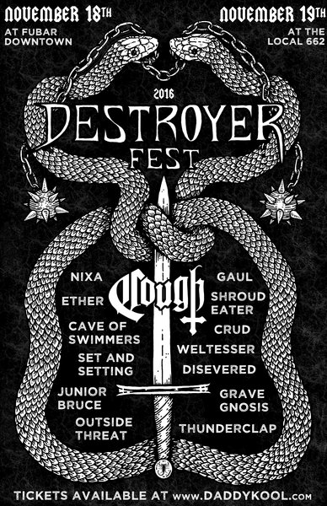

Metalheads unite! Next weekend (November 18th & 19th) Destroyer Fest 2016 crushes into downtown St. Petersburg with a bevy of brutality across all genres of the metal family. Headlined by Cough from Richmond, VA, the rest of the lineup all hail from Florida and several of the bands are from the local area. With the Tampa Bay area being known as having a hand in the birth of and continues to be an influence on American Death Metal, this festival is a great chance to check out and support some up and coming local and Florida homegrown metal in intimate venues.

NIGHT 1 LINEUP: Fubar
Outside Threat: noise/melodic from Ft. Meyers, FL
Ether: doom/sludge from Fort Lauderdale, FL
Grave Gnosis: occult black metal from St. Pete. FL
Disevered: death metal from Tampa, FL
Set and Setting: post metal from St. Pete, FL
AFTER PARTY NIGHT 1 -The Emerald
GAUL: blackened doom from Gainesville, FL
Thunderclap: heavy metal from Gainesville, FL
NIGHT 2 LINEUP: The Local 662
COUGH: doom/sludge from Richmond, VA
SHROUD EATER: doom/sludge from Miami, FL
Cave of Swimmers: Prog rock/heavy metal from Miami, FL
Weltesser: sludge/doom/punk from St. Pete, FL
Nixa: doom/sludge/psych/metal from Miami, FL
AFTER PARTY NIGHT 2 - The Emerald
CRUD - FL southern sludge from Miami, FL
Junior Bruce: stoner/sludge/doom from DeLand, FL

Destroyer Fest 2016 Friday, November 18
7:00 PM $12 adv single day; $20 2-day pass adv; $15 dos; $25 2-day pass dos
Tickets available here

Destroyer Fest 2016 Saturday, November 19
7:00 PM $12 adv single day; $15 dos
Tickets available here

Avoid Ticketmaster fees and pick up tickets at Daddy Kool Records
666 Central Avenue North, St. Petersburg, FL 33701
map

