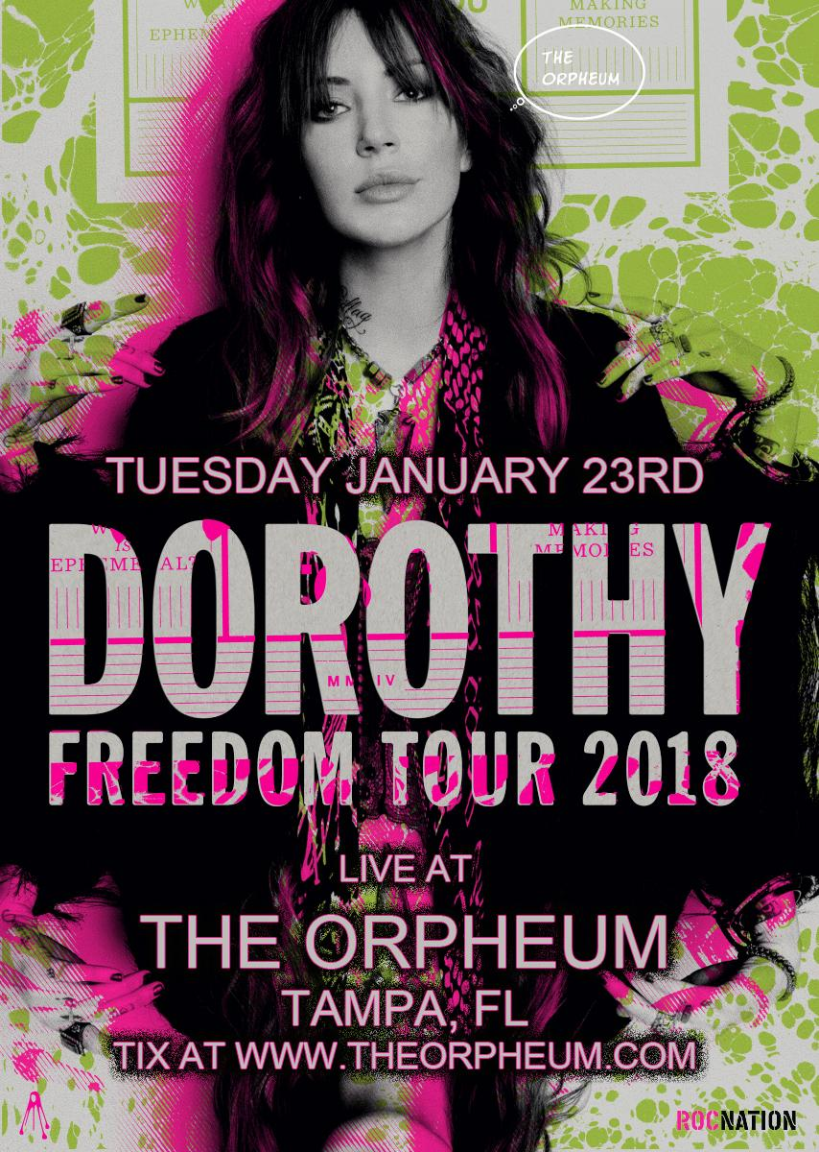
When Dorothy released their first project, a self-titled EP, in 2014. Rolling Stone deemed them "a [band] you need to know," and named them #14 on their 50 Best New Artists of 2014 list – they play The Orpheum in Ybor City on January 23, 2018.
Dorothy – Get Up
Dorothy - Wicked Ones
Dorothy - Dark Nights
Dorothy - Down To The Bottom
Dorothy
The Orpheum – Ybor City, Tampa, FL - January 23, 2018 - $13
Tickets available here

