Geoff Tate/Adrian Vandenberg | February 26, 2024 | Bilheimer Capitol Theatre, Clearwater, FL
With our local Clearwater date being the first of the co-headline shows featuring two of rock’s giants, original Queensrÿche singer Geoff Tate and axe man extraordinaire Adrian Vandenberg brought us fans in attendance a fantastic night of rock n roll. I arrived at the venue just shortly after the doors opened and not seeing any sort of line outside, figured it was a late arriving crowd. To my surprise, there was already quite the solid sized crowd inside, with a decent length line at the merchandise booth and an electric feel in the air for what we were about to witness.
One funny thing to note, before the show I was approached by a real friendly dude who introduced himself as a friend of a friend of mine and expressed his desire that he would forever be in my debt if I could help him meet Adrian Vandenberg. Seeing my perplexed look, he mentioned how I had gotten our mutual friend back stage to meet the band at the last show that I was here and he figured I had some sort of “I know a guy” hookup at this venue. I explained how his friend was “…just in the right place at the right time…” last show because even I did not know I would be meeting the band’s manager and our friend just happened to be chatting with me at that time. Still it made for a fun introduction to a new friend that I now have.
Vandenberg has not toured North America for an extensive run of appearances since 1986 and I was beyond fortunate to see him FOUR times in a five day period when he performed at the Sail Away party and on the 2022 Monsters of Rock Cruise. I had been a fan of his ever since my teen years when I had heard his “Burning Heart” song released in 1982. This man is such a guitar virtuoso it is amazing to watch his fingers fly over the frets.
Regarding this tour, Adrian Vandenberg shares: "Finally following up on the historic quote 'Go West, Young Man!' 'Young men' in this case, because I'm bringing my übertalented kick ass band with me to the U.S. of course. And it's about freakin' time guys. My first American tour since the WHITESNAKE 1990 tour, this is seriously exciting!! Some classic VANDENBERG songs and an XXXL order of songs from my WHITESNAKE years will get torpedo'd upon our American friends with a BANG. Can't wait to see y'all! BIG ROCK coming your way!!"
While once again, as a music fan I was blown away by the talent on display in front of me, but as a photographer I say there was some really bad lighting for the first three songs that I was allowed to photo. As it was happening, I kept thinking to myself, only the black and white ones are going to come out any good. Yet it was still a fantastic set with very little chit chat in between songs as the band was only allotted an hour to play. In actually it is not really a co-headline tour as billed, but from the happy faces I saw at intermission no one cared about that wording technicality, but we all agreed there is plenty of material he could have played way longer than an hour. The set list played heavy to his time in Whitesnake and was an absolute walk down memory lane for me as I specifically remember being in high school when the video for “Still of the Night” came out.
Geoff Tate, for thirty years (1982–2012) was the creative and driving force behind the progressive metal band Queensrÿche. There was an ugly spilt with the band, which I am not going to get into here and he forged ahead as a solo artist with the legal right to play certain Queensrÿche releases. There was not a single person in their seat once the lights went out and the show was about to begin. While the lighting was certainly better, now the photography obstacle was heads, hands and cell phones obstructing my photo path. First off let me just say that the man still has that amazing vocal range and golden voice. It was after my three songs to photo that Geoff brought out his saxophone and his backing band of a triple guitar attack (with dual leads) came together at the front of the stage, but by his fifth song, now we are getting into the “Operation: Mindcrime” days and I am once again taken back to my high school memories.
My friends and I were skipping school, drinking whisky, smoking weed and listening to an early version of ‘Operation: Mindcrime’. Being thirty eight years ago I do not recall all of the details, but I specifically recall that I would skip Geometry class while my friends had lunch. One of the guys in our group, his dad that was someone in the music business and he scored an early copy of “Operation: Mindcrime”. The only real thing I remember is how killer their sound was and I have been a fan of the band ever since. I also remember failing Geometry because I skipped eighty seven of the ninety day semester as it was way more fun to hang with my friends then go to class.
I also will say it is an impressive feat to sell out a show like this on a Monday night. Even if the venue holds just under a thousand people, it just shows there is still the love of live music and people will come out to see their favorite artists. I noticed that even Geoff seemed to get lost in the moment as the emotion of these legendary tunes hits home and I witnessed many people singing along with and playing air guitar or drumming along with the music. It really was a fantastic show and I heard nothing but satisfied rockers commenting what a great combination these two rock legends were having them share the same stage.
The co-headline tour continues with the following dates: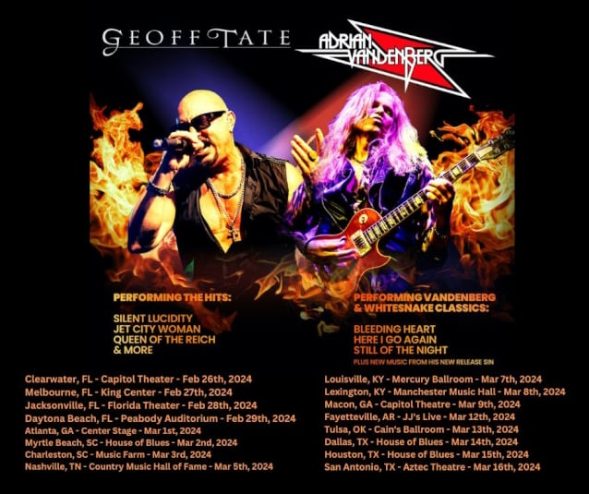

https://blabbermouth.net/news/geoff-tate-and-vandenberg-announce-early-2024-u-s-tour

