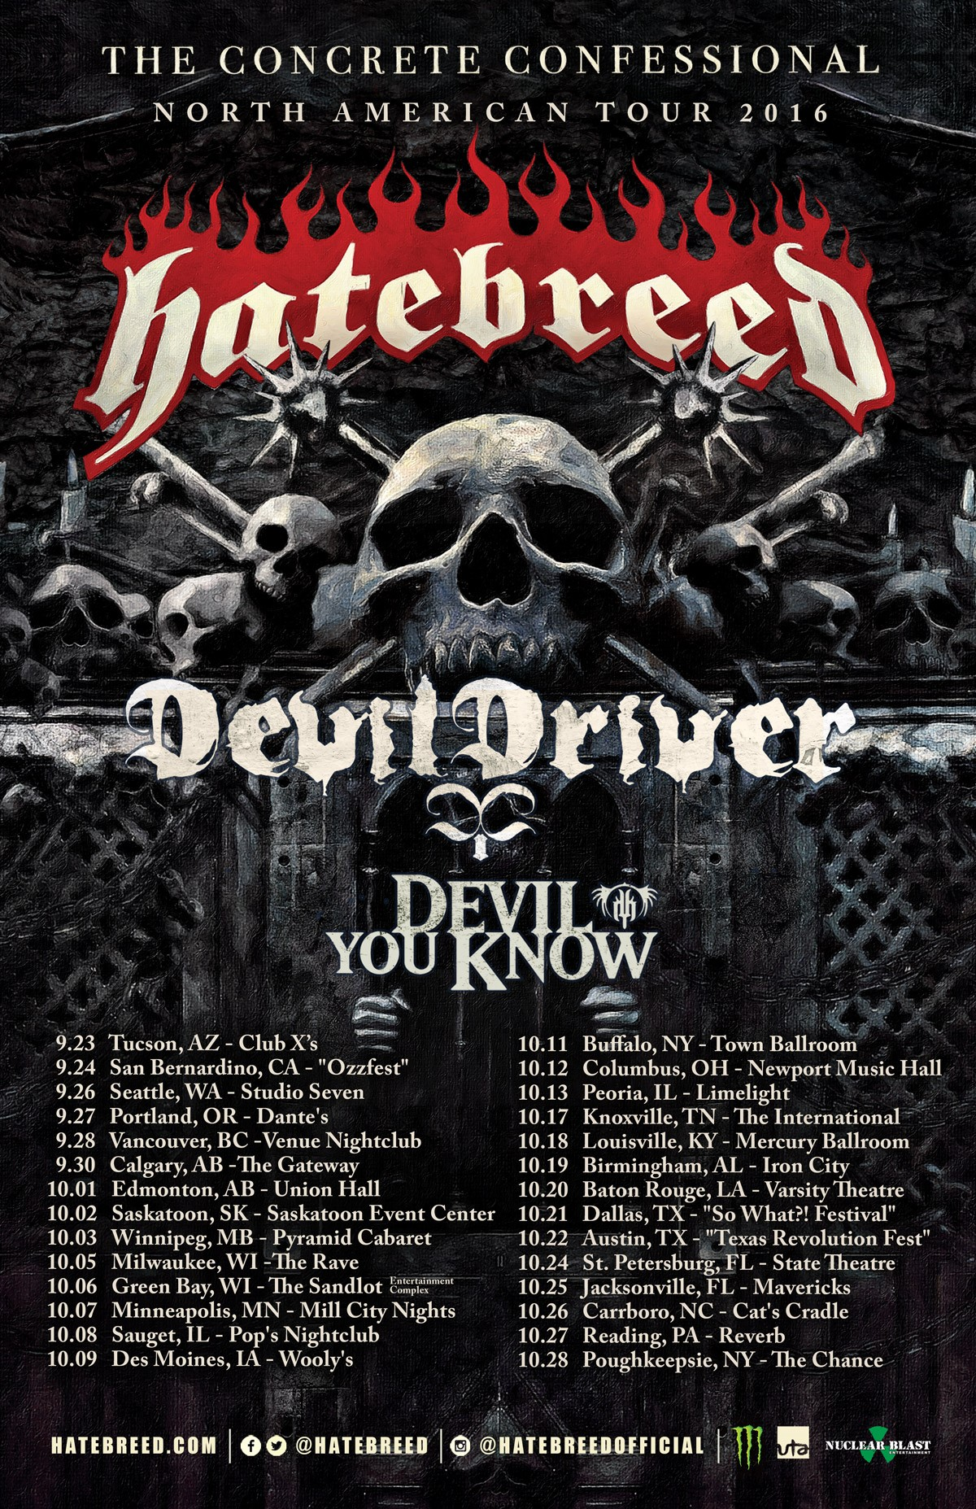

Being quite the lover of heavy metal music I consider listening to Hatebreed as my own personal form of self-empowerment therapy. There is no stopping yourself from head banding when listening to Hatebreed. Their music is heavy and crushing, aggressive and in your face yet lyrically their songs mostly encourage using any negative energy within yourself to fuel and push yourself in positive personal growth and empowerment. While this would be my fifth time seeing them live I am not a fan of them being labeled as metalcore as I think they are so far musically beyond the sound of some of the other bands in that branch of the metal tree. There is certain punk influence in their sound but if anything to me they are a defining band at the trunk of that metal tree. Hatebreed is touring in support of their latest release earlier this year, ‘The Concrete Confessional’ and 2009 was the last time they have played the State Theater in St. Petersburg which holds just over seven hundred at full capacity.
Devil You Know, a relatively new supergroup, opened the show. Formed in 2012, this band quickly garnered notoriety in the metal music world winning the Metal Hammer Golden Gods award for Best New Band in 2014. This was my second time seeing them and although they only had a thirty minute set they set out to get the night off to a totally metal start. At one point the lead singer paid homage to Florida, and the Tampa Bay area specifically, as being known as the birthplace of American death metal back in the 1980s and how not enough heavy bands come down here to Florida on tour. Their set was decent, I really think the venue needs to upgrade their sound system. It seems to me that every band’s vocals are not that clear as it seemed this way with all of the bands tonight and even a show I went to at the same venue two nights before. One thing I did take issue with was at the end of their last song the lead singer just dropped the mic and walked off the stage without any interaction with the crowd. Granted during the set he did thank everyone for coming out and checking out the show but come on man, we fans are the reason you are up there and not working a day job so I just thought it a little arrogant on his part as the rest of the band took the time to thank and applaud the crowd after their set.
DevilDriver was up next and even though they have been around since 2002 this was a band that going in I was not familiar with anything other than them covering the AWOLNATION song ‘Sail’ which I thought was freaking terrible (I am not a fan of the original either), so I did not pursue listening to anything else of theirs but I did have hope that they were going to be good live. There has been many shows that I have gone to where I am not familiar with the opening band(s) and I like going in not knowing anything about their sound so I can experience them live and fresh and decide from there. Wow was I blown away by this band - DevilDriver certainly gained me as a fan after seeing them live, these guys kicked ass, they played for forty five minutes and every second of it was awesome – their live sound is the epitome of what heavy metal is and should sound like so after the fact I in no way hold that crappy cover of ‘Sail’ against them. Their lead singer was very engaging with the crowd, keeping his in-between song banter to a minimum and absolutely just singing his heart out as the band was shredding all around him. I have already given a couple of their CDs a listen to off of YouTube and will for sure keep my eye out for when this band comes back to town.
The main attraction of the night was up next and wow there was electricity in the air as the crowd was chanting ‘Hatebreed…Hatebreed...Hatebreed’ as the lights dimmed and we were about to be shredded with their musical assault. They absolutely tore the roof off of the venue their set was that awesome. I have been to many shows at this venue and I have never witnessed the brutality I saw happening in the pit before me on this night at The State. The never-ending pit was an absolute circular blur of arm-flailing mass all set to the thunderous and relentlessly brutal sounds of this incredible band. Their set included every song of theirs that I wanted to hear with the exception of ‘Doomsayer’ (I know they cannot play them all). With their set list touching every one of their releases our ears were pulverized with many of what I consider their defining songs such as ‘Destroy Everything’, ‘Everyone Bleeds Now’, ‘In Ashes They Shall Reap’, ‘This Is Now’ and they included their new crushing hit ‘Looking Down the Barrel of Today’. Having seen these guys a few times already I knew ahead of time that Hatebreed is a band where their studio sound is really hard, if not impossible, to duplicate live, but the band feeds off of the energy from the crowd and was just unrelenting in their ferocity pumping out that glorious metal that we were all there for. Besides the muddled vocals for each band the only downer of the night was that they only played for an hour which left me and others in the crowd wanting more. ‘Hatebreed…Hatebreed...Hatebreed’ the crowd chanted again but once the house lights came on and the crowd realized there would be no encore I heard many instances of people in the crowd say just how killer of a show we had just witnessed.
Overall it was a kick ass show, I love the positive message in Hatebreed’s lyrics. If you are a heavy metal fan this is a band you have to see live. The intensity of their music is magnified ten-fold at their live shows, more than you could ever imagine by just listening to them – the band feeding off of the energy of the crowd and each song they play upped the intensity to a higher level – I would go see Hatebreed again in a heartbeat. \m/

