Shows I want to go to – Joe Bonamassa
Over the past couple of years my buddy Dave had tried several times to get me to go along with him to see legendary blues rock guitarist Joe Bonamassa every time the band came to town. Sadly I never took him up on the experience nor did I ever take the time to check out any of the band’s music. Fast forward to mid-February a couple of weeks ago and my other buddy Joe inquires if there are any contests to win tickets to see Joe Bonamassa that he is coming back and we try to win tickets. My peeps know I have a pretty good track record of winning tickets or helping them win via the various radio stations so of course once I did see a contest for said show I sent it to both Joe and Dave.
While I was away on the 2020 Monsters of Rock Cruise, Joe emails me and tells me that he won tickets and to put the date on my calendar. I told Dave and he was like “Dude, you are gunna freaking love that show!” Somehow being so wrapped up in post cruise photo reviews I neglected to request a photo pass and still did not listen to any of the band’s tunes ahead of time. I told myself that I wanted to go in ‘blind’ and hear for myself what my buddy Dave had been trying to convey to me for many moons.
Have you ever gone to see a concert not knowing anything about the artist or not hearing a single note of the music in the show ahead? Sure you have – there has been many times I have discovered bands that I liked with them being the opening band that I had never heard of opening for the headliner. The night of the show arrives and after we got settled into our seats and the lights dimmed – let me tell you I was instantly hooked from the first note this man played. Absolutely blown away is more like it. Never In all of my concert going days have I ever walked away from a show so completely blown away by the talent I had just witnessed and hungry to hear everything in his discography that I could put my ears on.
We are just about one month since that show and I have been using this work from home quarantine time to listen to as much as I could of his thirteen solo studio albums, seventeen solo live albums, three collaboration albums, and the four studio albums as guitarist with Black Country Communion. Let me tell you, Joe Bonamassa has become one of my favorite artists and I have made mention to several of my concert circle friends that “there is no way I will ever miss one of his concerts again if I am able to go!”
Being a known metalhead one might say that Joe Bonamassa’s music is quite a change of pace for me, but I know what I like and I know talent. And this man has exceptional talent with his instrument, his vocal delivery and his songwriting abilities. I 100% enjoyed his concert and even though I was not up front taking photos I was able to snap a few decent shots from our seats.
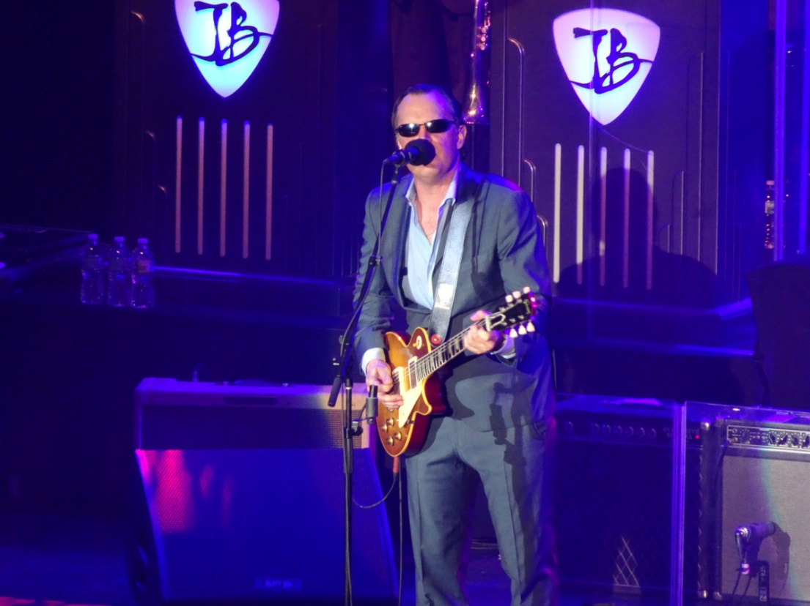
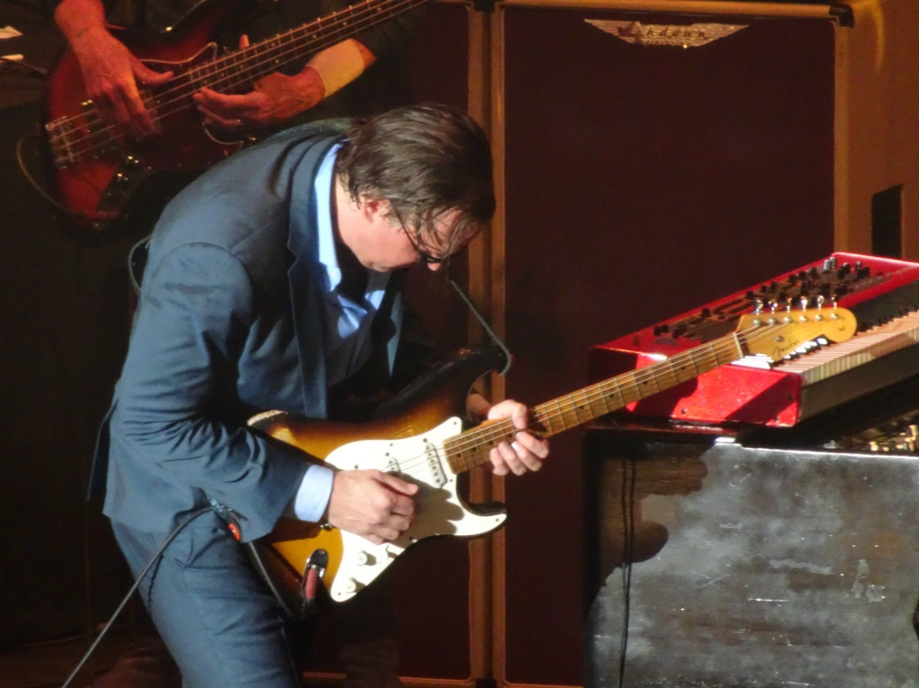
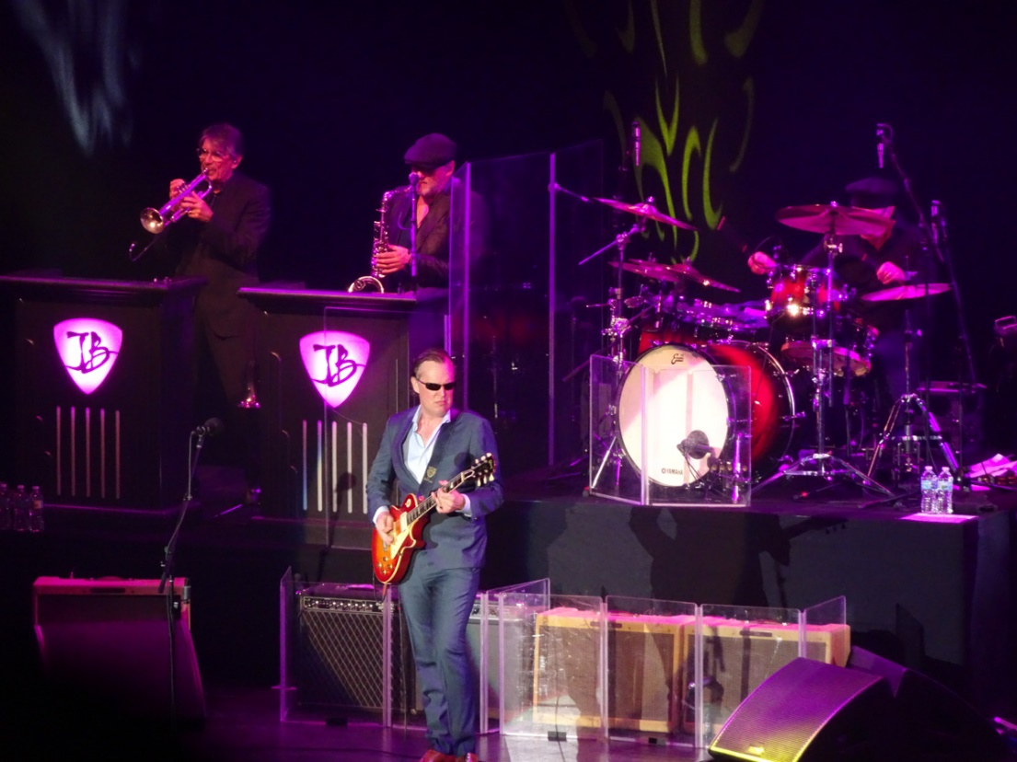
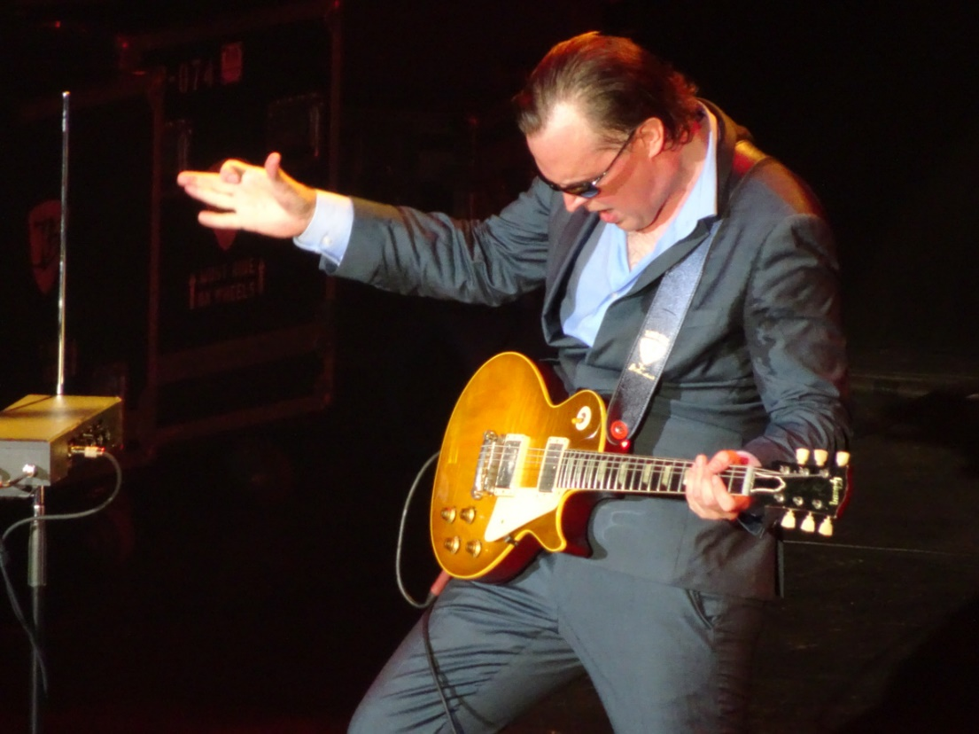

Setlist from February 24, 2020 at Ruth Eckerd Hall in Clearwater, FL
Tiger in Your Tank (Muddy Waters cover)
Evil Mama
King Bee Shakedown
Just 'Cos You Can Don't Mean You Should
If Heartaches Were Nickels (Kenny Neal cover)
Sloe Gin (Tim Curry cover)
Don't You Lie to Me (I Get Evil) (Tampa Red cover)
Conversation With Alice
Blues of Desperation
Well Well (Delaney & Bonnie cover)
I Can't Quit You (Willie Dixon & Memphis Slim cover)
Little Girl (John Mayall & The Bluesbreakers cover)
Just Got Paid (ZZ Top cover)
Encore:
Woke Up Dreaming
Mountain Time

Here are a few of my favorite tunes of his. The blending and mixing of the horns, his magical guitar, his soulful and passionate lyrics (especially their delivery) and the background vocals will be permanent fixtures in my playlists:
Joe Bonamassa - "Evil Mama"
Joe Bonamassa - "Just 'Cos You Can Don't Mean You Should"
Joe Bonamassa - "King Bee Shakedown"
Joe Bonamassa – “Mountain Climbing”
Joe Bonamassa - “Redemption”
Joe Bonamassa – “Riding With The Kings”
Joe Bonamassa – “This Train”

His is a show than I simply cannot wait to go to once again.

