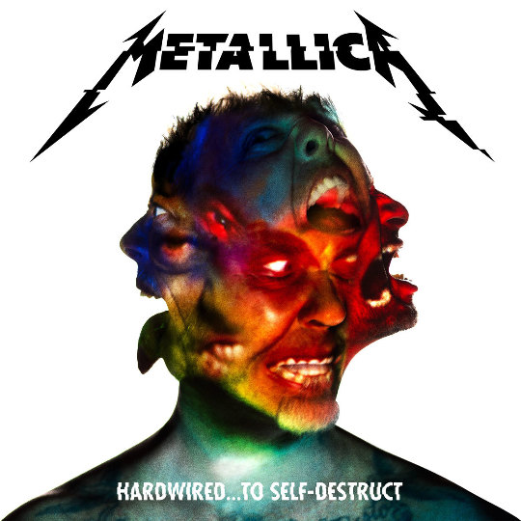

Two months into ‘Hardwired… to Self-Destruct’…
As a longtime fan of Metallica, literally I was hooked the first time I heard them the day ‘Master of Puppets’ was released back in 1986, I held so much hope of the potential for the rest of ‘Hardwired… to Self-Destruct’ to kick-ass and rank up as one of their best releases after Metallica strategically unveiled three singles leading up to its release date. I was up in Minneapolis just two days away from seeing them live this summer when I got a listen to their first single ‘Hardwired’. I immediately felt I (and many other longtime diehard fans) finally had the old raw and hungry sounding Metallica thrash sound back, like I was listening to a bonus hidden track that had been discovered after all these years on ‘Kill em All’. I mostly enjoyed ‘Moth into Flame’ as a solid new jamming song and thought ‘Atlas, Rise!’ was just absolutely their best song in years, if not decades, which I had almost overplayed it to the point I was thankful the band released videos for all of the news songs in the days leading up to the actual release. The section starting about 3:12 into ‘Atlas, Rise!’ leading up to Kirk’s solo is that exact raw, crunchy, heavy old school Metallica sound that I have been so hungry for in their new music. All I could think was these first three singles are really freaking good, please let the rest of it kick ass too!
Now, after a month of having the CD on near constant repeat in my car and multiple plays all the way through via YouTube at home and I am certainly pleased by the offering of these metal icons and am certain there is a definitive influence within most of the new songs spanning their entire discography. For me in particular the first four Metallica CDs, as I hear bits and pieces within the songs on ‘Hardwired… to Self-Destruct’ more so than any of their other releases. Of which I am not knocking against or trying to make comparisons to, as I hold those first four releases of theirs in very high regard, I take it more as them paying homage to their roots, evolving with and expanding on the sound that brought them to where they are today.
In full disclaimer here, as I consider myself a longtime diehard fan of theirs, for the fact that after all of the ballads that came out on the ‘Black’ album I was one of the fans who thought the band sold their sound out for radio airplay, losing their thrash edge which I admit made me more critical of their releases after that. Sure there were some great and classic jams on the Black album and a few other good ones on subsequent CDs, but no releases since ‘...And Justice for All’ were a must listen to all the way through for me.
That is why I held out so much hope after hearing the three songs the band dropped before this long awaited release and seeing the live premier of ‘Hardwired’ at the Minnesota show that we were in for full on thrash metal. With so much hype leading up to this release I avoided reading any of the early reviews as I did not want any preconceived notions or opinions before I had a chance to hear it for myself. Overall I am pleased with the outcome of the eight years plus wait we fans have had to endure for new music from Metallica.
Because this is such a long awaited release I offer a few of my thoughts on each of the songs, rather than the CD as a whole:
‘Hardwired’ explodes right off the bat and immediately it reminded me of that ‘Kill em All’ style thrash sound but with a more refined and cleaner sounding James. It never lets up with an in your face ferocity and it is easily one of my favorite songs on here.
So far ‘Atlas, Rise!’ is my favorite on here but again that goes back to just how much I love the classic crunching sound of this song, and seeing the video as I heard it the first time just gave me a sense of how focused the band was on reclaiming their throne in the metal realm. For me this is the gem on the CD, the one that will go down as one of their all-time classic songs.
With ‘Now That We're Dead’ I hear a hint of a slower ‘Seek and Destroy’ in the main riff on this song. It has its own heavy and catchy groove as the song evolves along, but musically this one sure takes me back in time. It was one that I did not prefer as much the first couple of times time I listened to it, but it did not take long to work its way up as another one of my favorites on the disc.
‘Moth Into Flame’ certainly grew on me the more l listened to it. At first I was not that much a fan of the harmonic melody section that leads into the chorus, but the more I listen to this one the more I am liking it all the way through. It also has that classic heavy Metallica sound that I enjoy so much.
There is a great guitar riff that hooked me once the intro gets going on ‘Dream No More’, I wish this song would have kept that tempo, once the vocals start it slows down but still with a heavy beat. It felt a bit gloomy and sludgy reminding me of an evolved version of ‘The Thing That Should Not Be’.
I consider ‘Halo on Fire’ the ballad on here with its clean vocals and softer sound, I fell like every time the song tries to get going it slows itself down. The second half of the song is a little heavier and while I have given this one more than enough listens to give it a chance it is just not the Metallica sound I prefer.
‘Confusion’ immediately reminded me of a mix of both ‘Am I Evil’ and ‘Creeping Death’ (with ‘Creeping Death’ my second favorite Metallica song behind ‘Blackened’). Its opening, was another one that I initially did not care to much for as it feels like they are holding themselves back from just wide open jamming by slowing the song down in parts but again, the more I listen to this one the more I think it is one of the better songs on the disc.
‘ManUNkind’ has an interesting time signature that I like more and more with each time I hear it. It has the heaviest bassline I have heard on the disc, and for me while does not have that smooth transitional sound into their trademark heavy crunch, I cannot picture this song sounding any other way than it does so it holds curiosity for me to try and hear something new musically each time I hear it from the last time that I played it.
With ‘Here Comes Revenge’ I heard some ‘Lepper Messiah’ in the opening sequence before the vocals start. While this is another song with slower, cleaner vocals, this one does finally get going and holds onto that crushing sound, until the next verse, but once that section is over the song absolutely jams the rest of the way. This one was another that I was a little hesitant on the first couple of listens, but this song has quickly gained near classic status with me over this past month to where it is right up there with Atlas, Rise! For me.
‘Am I Savage’ is one that is still growing on me the more that I hear it, another clean intro gives way to a heavy groove sound, there are a few small sections in this one I wish were rearranged a little, but I like this one, it has what I think is the heaviest, most deliberate crunch on the CD after the second verse before and through the solo.
‘Murder One’ is Metallica’s tribute to the legendary Lemmy (and Motörhead, who, in James’ own words said there would be no Metallica without the influence of Motörhead), who sadly passed away at the end of 2015. The song is definitely heavy and lyrically pays tribute to many of Lemmy’s catch phrases. For sure one of my favorites on the CD.
Metallica has been known to save the last song on several of their releases to be the most frantic and speed metal sounding musically of the new songs on that particular release. ‘Spit Out the Bone’ is as crushingly thrashy as the opening song ‘Hardwired’ was, reminiscent of ‘Damage, Inc. for me. This one will certainly leave you with a sore neck as it is a solid jam, old school sounding Metallica, raw and heavy.
Two months into ‘Hardwired… to Self-Destruct’ I would rank it solidly just behind their first four releases with the potential to climb higher on my list of favorite Metallica CDs. I am elated to hear the direction this new CD takes musically with just how focused the band sounds on getting back to kicking ass and sounding like Metallica again. Whether you are a hardcore Metallica fan or if this is your first experience with this band I highly recommend picking this one up and adding it to your music collection. The band sounds good and the production is excellent in quality, every song and note sounding clean and crisp. I think this release is 78 minutes full of Metallica at the best they have sounded in years. I also suggest catching Metallica live as the band will soon confirm a North American tour in 2017 and at this point we fans are just waiting on dates to be announced. \m/

