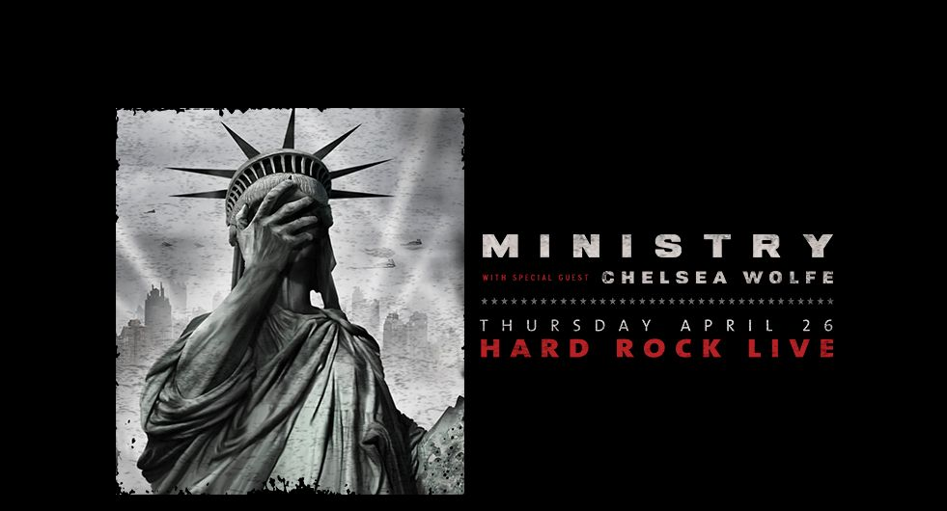

On April 26th Ministry rolls into the Orlando Hard Rock Live in support of their recently released fourteenth studio album, AmeriKKKant. Having been one of my all-time favorite industrial metal bands for over two decades, it was an agonizing wait in the five years since their last album had been released. This promises to be a very spirited, bone-crushing and high energy show. Seeing lead singer Al Jourgensen’s mic stand alone is worth the price of admission for this show, not to mention the wall of sound that is sure to blow the audience away. This band is one of the pioneers of the industrial metal sound and movement, if you are a Ministry fan then this is a show that you need not miss! \m/
Ministry - Antifa
Ministry - N.W.O.
Ministry - Just One Fix
Chelsea Wolfe - Feral Love
Ministry with Chelsea Wolfe and God Bombs
Hard Rock Live - 6050 Universal Blvd, Orlando, FL 32819 – April 26, 2018 - $45 Lower Balcony, $40 Upper Balcony, $35 General Admission
Tickets available here

