Monsters of Rock Cruise | Live Review & Concert Photos | February 24 – March 1, 2019 | Royal Caribbean’s Mariner of the Seas

Unlike the 2018 cruise where my friend Mike and I booked just days before departure, for the 2019 Monsters of Rock Cruise (MoRC) my brother-in-law John and I booked the minute the alumni booking opened up. With John having heard my stories of how much fun I had, seeing my photos from last year’s cruise and another solid line up of bands initially announced, we knew we were in for one hell of a fun and rock filled week – we just had a very patient eight month wait for the adventure to arrive.
While I had held out hope that the two bands I discovered and thoroughly enjoyed from last year’s cruise would be added to the already kick ass lineup, they were announced as playing on separate nights for the two pre party events held at the Magic City Casino in Miami. Both Beasto Blanco and The Iron Maidens totally blew me away on last year’s cruise and I was eager for more.
The drive to Miami was uneventful, thankfully and the hotel we strategically selected had a very convenient shuttle to the casino for the show. Among those in the crowd, myself included, there was serious eager anticipation in the air for both The Iron Maidens this evening and the cruise the next day. As soon as these very talented ladies took the stage they ripped note for note into Iron Maiden’s classic “Aces High”. These magical musical tunes were like pouring fuel onto a fire as the crowd simply went wild and never let up their energy, nor did the band through a nine song set list that included several of my all-time favorite Iron Maiden songs. I wish The Iron Maidens would have been the headliner instead of the opening band as we would have been treated to a longer set but I was just thankful for having experienced them live for my fourth time.
After the band was finished we met up with my friend Ben who I met on last year’s cruise and kept in touch with. We hung out for a little bit until the ladies from the Iron Maidens came down to the merchandise area for pictures and autographs with the fans. The whole time since arriving at the casino I had been keeping my eye out for any and all of the Beasto Blanco band members figuring they would be there as well having played the night before and a show scheduled the next night close by in south Florida.
Ben, his sister, John and I decided to forego the rest of the pre party show and seek out nourishment. We took the shuttle back to the hotel and walked to a nearby restaurant. Wouldn’t you know that just as we were finishing our meal in walks the entire Beasto Blanco band and their entourage. It was certainly a metal and memorable moment but no way was I going to break one of the unspoken cardinal rules I had learned on prior rock cruises. You do not disturb an artist while they are eating. The whole cruise is based on and encourages fan interaction with the band members but they are people too, they too need to eat and it is just not polite.
The day of finally arrives and John and I make our way down to the cruise port. As we queued up in the line to board inside of the terminal, three of the many members of ‘Thee Rock N' Roll Residency’ started an impromptu acoustical sing-along jam. I made mention to John that this was just the beginning of the rock and he and I sat down and started to review the band schedule for the days ahead. Just like last year there were timing conflicts of literally too much to do and not being able to be in two places at once with bands playing at near the same time where decisions would have to be made as to which band you wanted to see more than another. Several songs later and to even more applause than the jam got the ship opened for boarding and our adventure truly began.
The MoRC is all about enjoying and embracing the brotherhood all guests onboard share as live music fans and the cruise is one big immersive experience interacting with other guests, the band members and their entourage, for me the other photographers and of course rocking out to a plethora of available shows. On a cruise like this you never know who you are going to be sitting next to in the dining areas or sharing an elevator with. Once again the encounters we had with the artists were just too numerous to list all of them out but one interaction stands out tall above the rest.
Just like on last year’s MoRC, Rick Allen, the drummer for the recently Rock and Roll Hall of Fame inducted Def Leppard, has a display gallery onboard of his artwork. I do recall wandering in there a couple of times last year out of curiosity and certainly admiring his talent with an artist’s brush. Knowing that John is a rather accomplished painter in his own rights I made sure to mention that we needed to go visit the gallery. I think it was either our second or third trip in there when we were having another browse of the paintings and artwork when I look over and motion to John to look over and see who was just chilling in a chair just talking to people as if they were his family. “Dude it is Rick freaking Allen” says John and he strolls on over and strikes up a conversation asking how long Rick has been painting. Without a pause Rick stands up puts a hand on John’s shoulder and says “Ever since I was a child.” That was the beginning of a very spirited, passionate and fascinating conversation about painting techniques, brush strokes and the common bond between those sharing common interests. As much as I wanted to ask if I could snap a photo of John and Rick together I did not want to ruin the genuineness of the moment that Rick took as much time as he did to converse with us as if he had known us since his first time painting.
Once again this year I made several new acquaintances from the pool of other media approved photographers and rekindled friendships from several others who I had met aboard last year. I thought it was the coolest thing ever to have a couple of the staff photographers not only remember me but also by name!
John and I both want to give a big shout out to the crew behind the scenes and all of the venue security people who do their utmost to accommodate the crowd’s desire to get into the venues as soon as possible. It is the people you do not see who make this whole thing happen and we are grateful for what was once again the funnest week ever!
This year’s cruise was on the same class of ship and had the exact same deck plan layout as last year’s MoRC so it did not take much time to acclimate myself to the routes I remembered as being the fastest in between the different venues aboard. As John and I roamed the ship before any of the festivities started the one big difference I noticed this year was a massive stage on the pool deck that literally dwarfed the one I remembered from the year before. After a quick lunch we settled in for our first show in the ship’s two level theater as Lies, Deceit & Treachery kicked off the first of what turned out to total FIFTY shows that I saw over the five days and nights aboard. After the mandatory safety drill we were finally underway with old school cold blooded Kix rocking the pool deck stage as we left Miami in the distance.
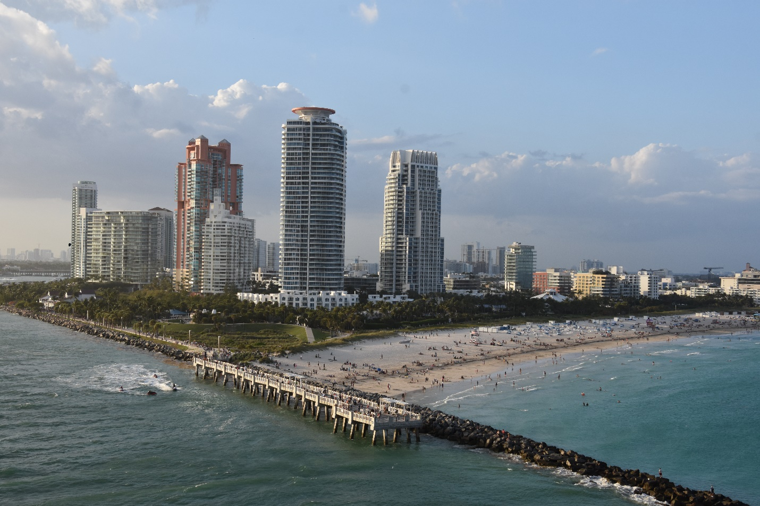
Departing Miami - Kix rocking the pool deck as I took this
The night just continually kicked ass from there as the mighty Queensrÿche took to the theater stage, then it was off to see sets by Vixen, Mach 22, Danger Danger, Faster Pussycat (and their already MoRC historically infamous poolside bash), Killer Dwarfs, Eclipse, and Jetboy. Surely the tone was set for what would be an epic four more days as once again like last year I had already discovered some killer bands and music that I had not been familiar with prior to the cruise. This day I was most blown away by Eclipse – hailing out of Sweden, they had a huge and faithful following who showed up in strong support at the midnight hour when the band took the stage. Wow did this band freaking ROCK!
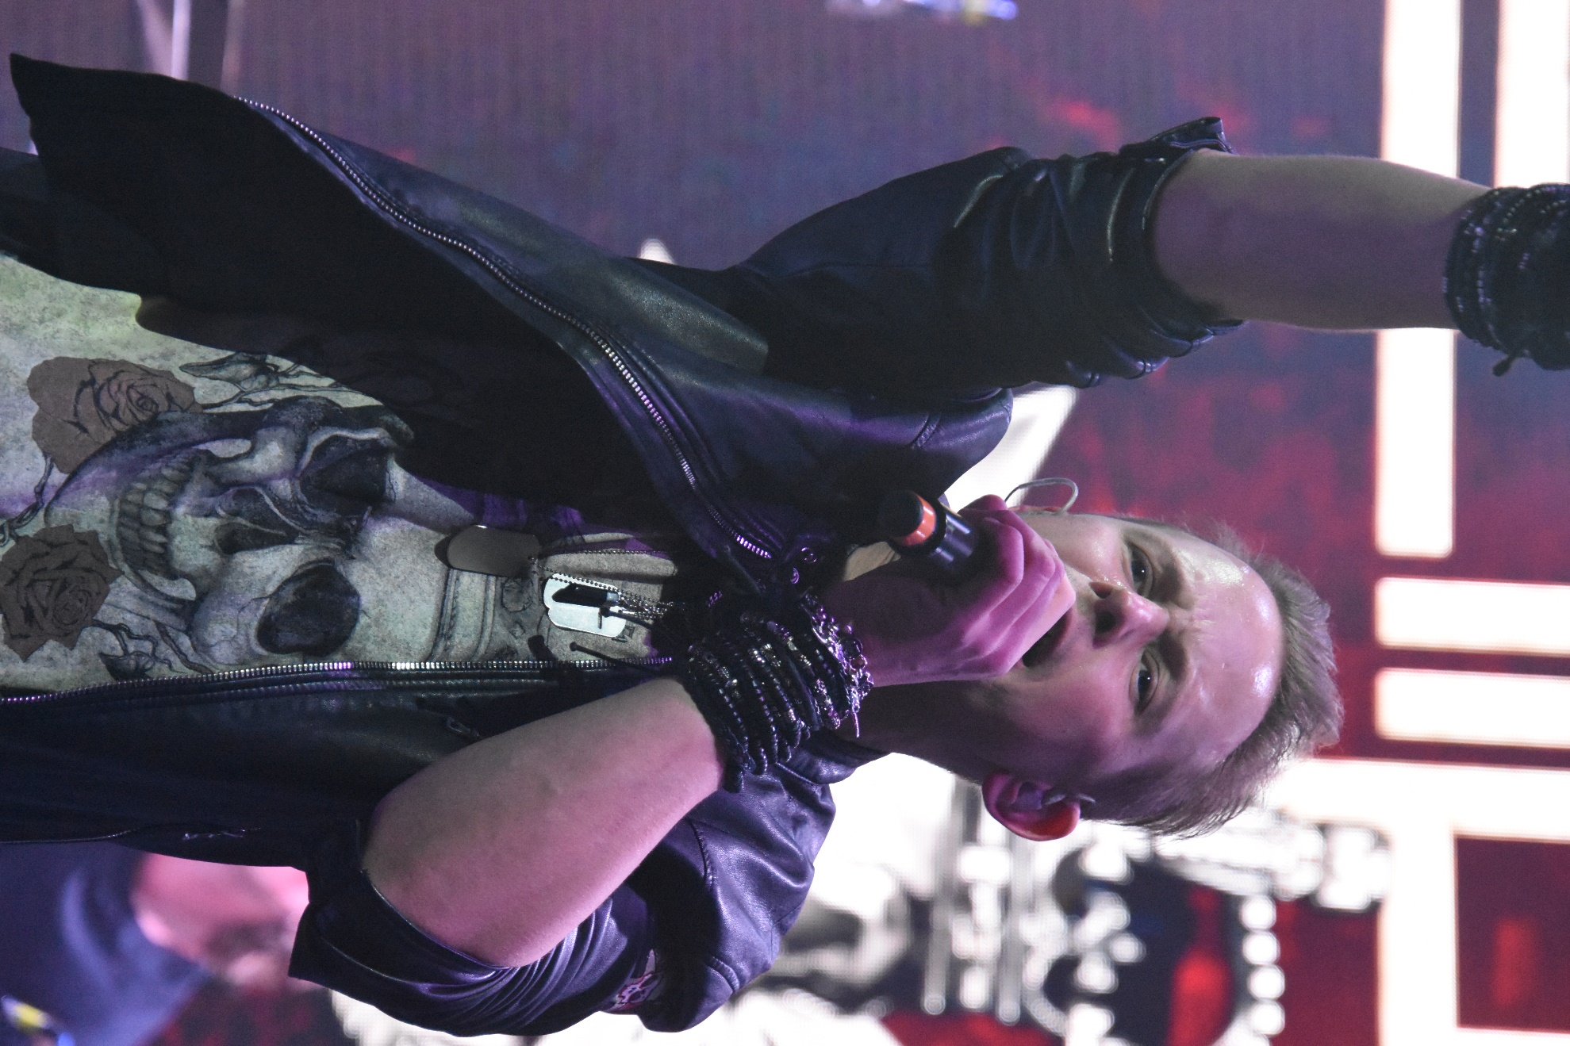
Vocalist Erik Mårtensson of Eclipse
Breakfast conversation for day two was enthusiastic between John and I at just how killer the first day had been then turned to excitement at the schedule ahead for the day. This was a day at sea and also our first opportunity to attend the band meet and greet photo opportunities. The night before we had that ‘cannot be in two places at once decision’ and opted to skip the first of the band photo sessions. As the people watcher I am, as much as I enjoy my opportunity to shake hands with the band members and throw the horns as we take the photo, I also enjoy the moments where I see the real hardcore fans of any given band really appreciating and embracing the moment of getting to meet some of their musical idols. Ben had mentioned to me after the act that when he got the chance to meet Udo (Dirkschneider, of the band U.D.O.) that for him it was like meeting one of The Beatles as Udo is such a legend in heavy metal history.
Brian Howe kicked off the music for us this day, intermixing Bad Company songs with some funny stories of his life’s adventures along his musical career. XYZ totally rocked the pool deck stage, and Pink Cream 69 nearly brought the ship to a tilt tearing up the theater stage. A second Vixen show in two days, and then it was time for my first ever Skid Row show. I caught the second Mach 22 show (these guys were really kick ass, one of my new band discoveries from the day before) and then was on my way to the pool deck for Lies, Deceit & Treachery once again. I squeezed in most of the Faster Pussycat set between the musical highlights of day two for me, Tom Keifer Band, and U.D.O.
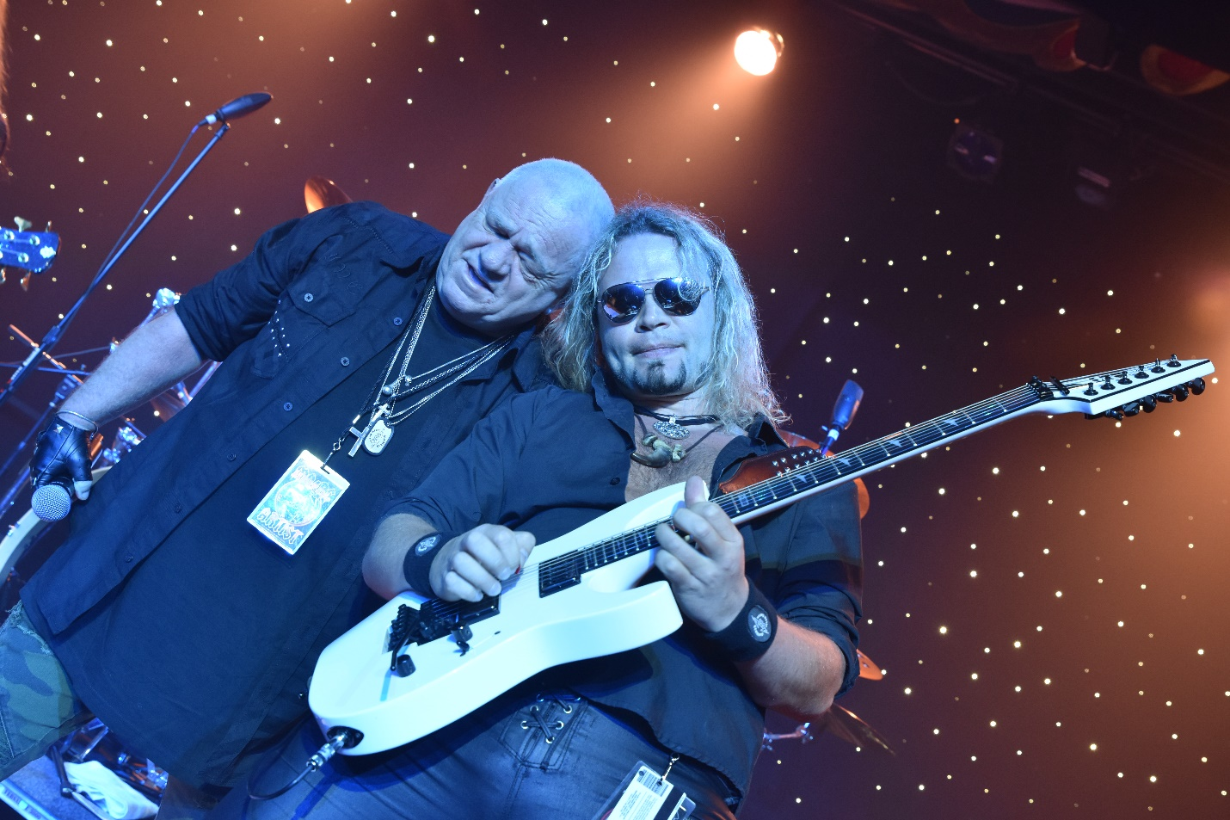
U.D.O. absolutely shredding

For our third day aboard once again breakfast talk resumed with the same enthusiasm as the day before. Killer shows once again had been seen and more were ahead on the schedule. In fact this day we visited Ocho Rios, Jamaica, but the schedule ahead was so jam packed with band photos and shows that we opted to remain onboard and not even step foot in this tropical paradise.
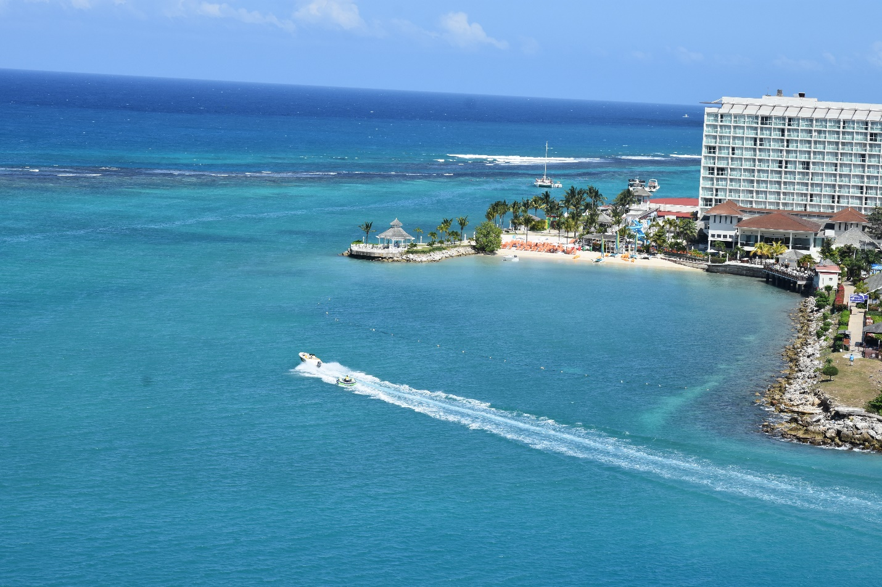
Ocho Rios, Jamaica
Tora Tora hit the stage for us first, followed by a blistering set by Femme Fatale. Extreme took the pool stage as we departed paradise and rocked the boat to near tipping point. Tesla absolutely rocked the house in the theater and had everyone on their feet cheering them on as they are the unofficial ‘house band’ aboard, being veterans of multiple headliner stints onboard MoRC over the years. Next up was guitar virtuoso Richie Kotzen who can simply make magic with is axe. We then were off to see and hear the BulletBoys outside on the pool desk stage and then shows by Kix, Y&T and Saxon. For as many kick ass bands as I had seen this day the musical highlight for me was Matalichi, a metal mariachi band. They played after the midnight hour out on the pool stage and man what a treat seeing this band was. As a lifelong born and bred metalhead it was pure joy to hear some of my favorite metal songs played in such a style and delivered with such comedic intent that the result was probably the funnest hour long set I experienced on this year’s cruise.
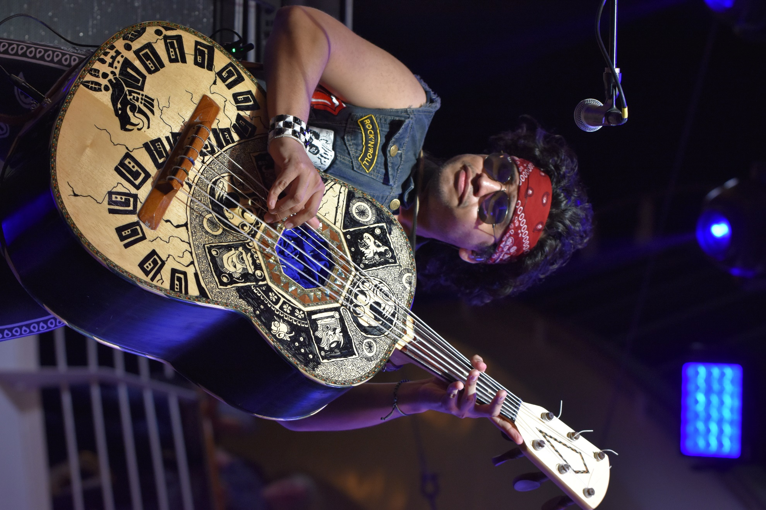
Metalachi
Our fourth day began as the prior two had. It was another day of having a tropical getaway at our fingertips yet again the daily schedule was packed full enough there was just no time to take in all the shows and everything this experience has to offer AND get in some beach time on the Isle of Labadee. U.D.O. was my first show of the day and that led to my first ever experience with Rose Tattoo. This time as we departed land Tesla took to the pool stage and picked up right where they left off in the theater the day before. It was during this set where I got my signature photo for this cruise with guitarist Franks Hannon looking like his hair was on fire with it blowing in the breeze and a stage light behind him.
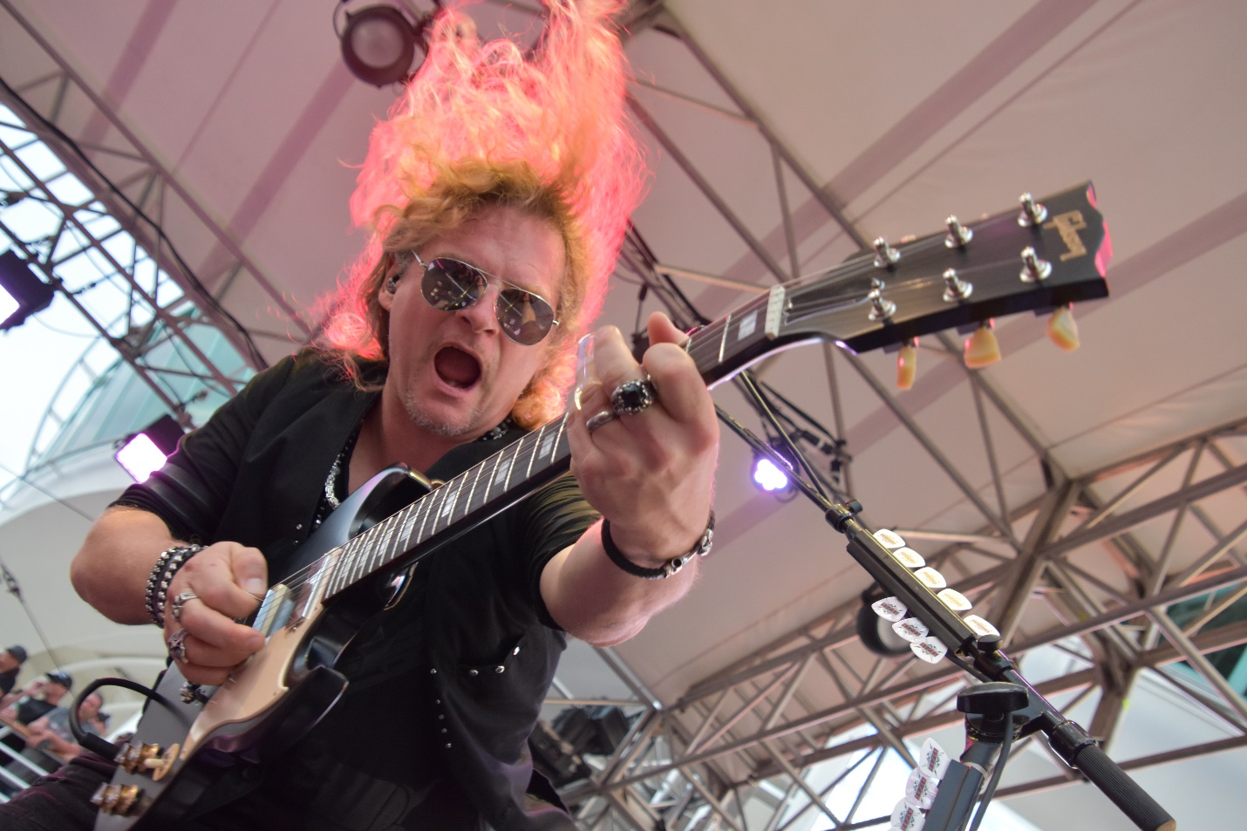
Frank Hannon of Tesla on fire
The Tom Keifer Band, Y&T, Saxon, Metalichi, The Quiorboys, Richie Kotzen, and Tora Tora rounded out who all I saw the rest of the evening, with each of those bands being their second and final performance aboard so I did my best to savor every note and moment.

Our last day at breakfast was met with a hint of sadness in that it was almost over but yet there was still a full day of some serious rock ahead and I did not want it to end. The day was filled with nonstop rock as after Michael Grant and The Assassins took to the pool stage once again crisscrossing the boat back and forth to the various venues I spent the day rocking out to shows by Extreme, Eclipse, The Quiorboys, Black ‘N Blue, BulletBoys, Femme Fatal, Brian Howe, and the next thing I know we are taking photo positions for what would be the final show I would see – Queensrÿche took the stage to an overflow crowd and we all embraced the awesomeness that we all had just experienced after five days of nonstop rock and roll and the comradery between friends, new and old.
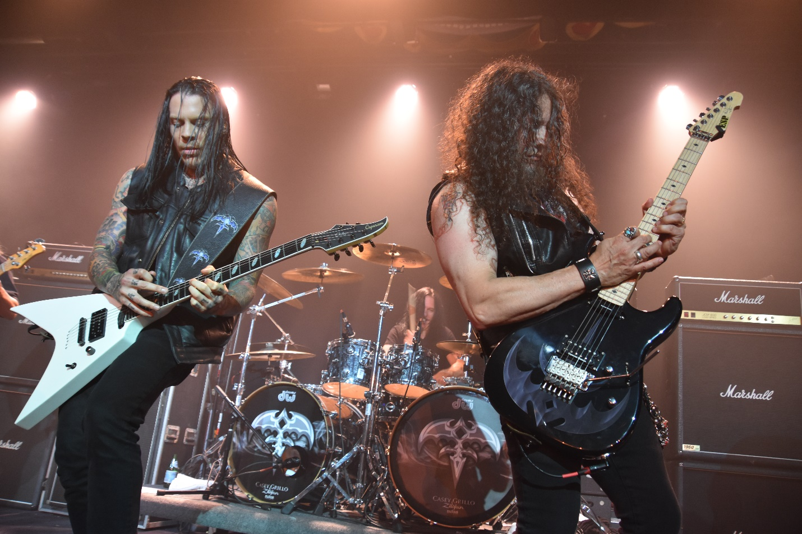
Queensrÿche
Just like last year I can say that the entire trip was a blast. Counting the pre party I got to see fifty one sets over a six day period – how kick ass is that. John did not keep track of who all he saw but I know his show count was not far behind mine. Once again I discovered bands that rocked that I had not been familiar with prior and once again new friendships were made for both John and I. As I write this we are anxiously awaiting the initial information on bands and alumni booking dates so we can get our reservation in for next year’s Monsters of Rock Cruise. \m/

