Pour Some Shout at the Devil on Me
Never in my life had it taken three years from the date of a concert announcement for the day of the show to finally arrive but that is where I find myself this July 8th morning. The "Stadium Tour" featuring co-headliners Def Leppard and Mötley Crüe with supporting acts Poison and Joan Jett and the Blackhearts was originally announced in 2019 to commence in 2020.Well, we all know the world as we knew it in 2019 came to an abrupt stand still in the Spring of 2020 with the arrival of the Covid pandemic. The tour dates were rescheduled to 2021 in the hope that some sort of normalcy would return by then, but alas the pandemic held on longer than any of us wanted. When the tour dates were rescheduled a second time to 2022 my initial thought was 'Lord, please let this finally happen!'.

I think rockers everywhere held their breath as the days got closer to the tour start and we all exhaled a sigh of relief once the first few shows on the tour actually happened. I was not able to attend the show closest to me in Orlando, but by my standing as the official/unofficial Chief Metal Officer of the company I work for, my boss was able to secure me two tickets to the show in Chicago.

The day of the show finally arrives and I find myself sitting in a Lake Bluff, IL coffee shop awaiting the arrival of our company's official/unofficial Chief Metal Maiden. Once she completes a half day of work we can figure out our best way to commute to Wrigley Field. There we will rejoice with over 40K of our rock-n-roll brethren and witness this concert that I have been so excited to see for over three years.

The moment of departure arrived and now came the difficult part especially for an out of towner. Even though the Maiden lives in the northern suburbs, rarely has she ever made the trip to the ballpark via the train. After calculating the trip from the Metra to the purple line, then over to the red line which would deposit us right next to Wrigley Field, I made the command decision to take the Metra to the closest stop to Wrigley and then Uber the rest of the way. Problem solved!
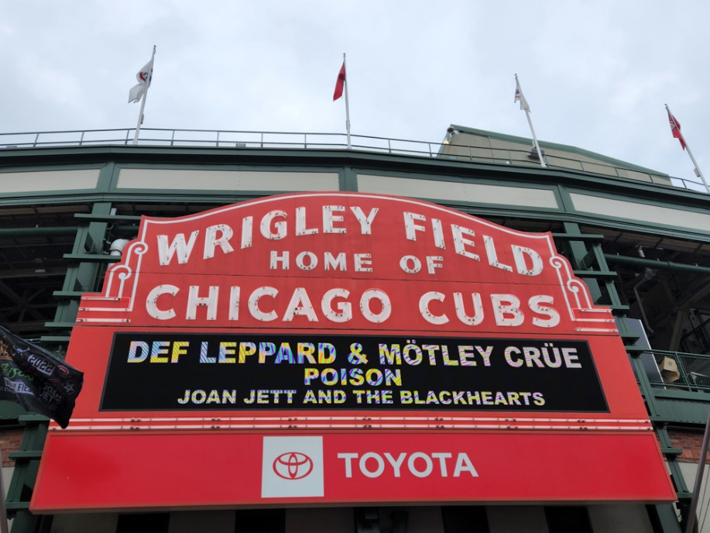
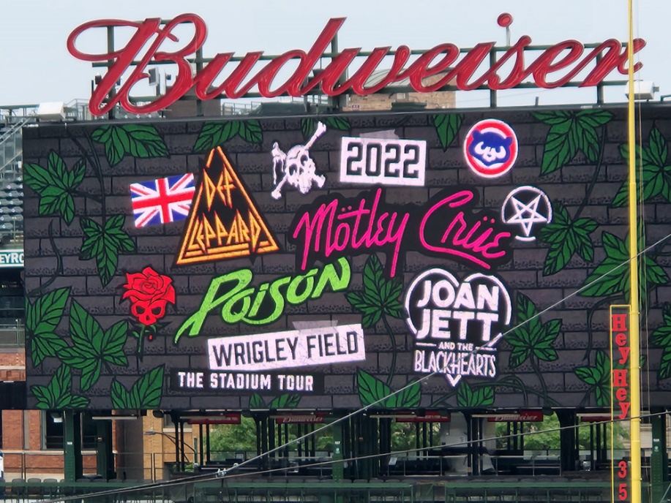

With a stellar lineup of Joan Jett & The Blackhearts, Poison, Def Leppard and Mötley Crüe, by my math these four iconic bands have an astounding collective 172 years of rock-n-roll history behind them from each band’s origins. Let me say that again – 172 years of combined history. Never before had I seen a show with so much history involved. Maybe the Rolling Stones, but that would be only if you added up the band member’s age.

Opening the show and hailing from literally all over the globe (Poland, Hawaii, Los Angeles, Argentina, and Dallas), Classless Act was on stage first and sadly because they played so close to the doors opening I do not think many people had the chance to really check them out beyond hearing them while in line at the merchandise tables, myself included. I am certain their blend of tasty rock riffs were heard by thousands and from what I could hear this band certainly deserves more of my future attention. From the things I have heard from friends, it will not be long before Classless Act is doing a headline tour of their own. I was able to catch a few quick glimpses of them and they looked like they put on a lively set even though they were only allotted 20 minutes based on the set times I had seen for the day.

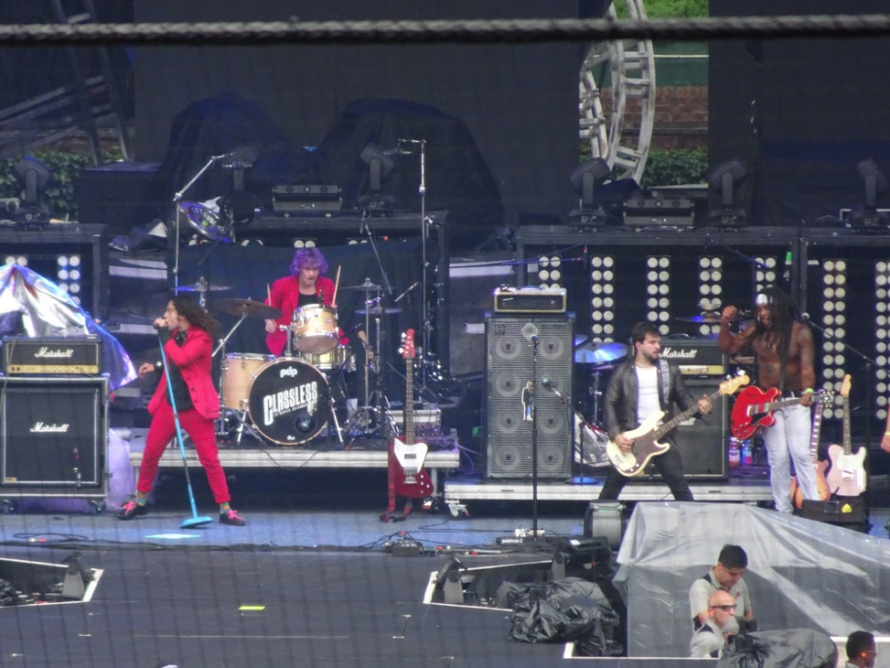

As Joan Jett & The Blackhearts took the stage I would say the crowd was already maybe at like 60% of the capacity, not bad for being such an early start. This was my fifth time seeing her and her band. Every single show of hers I have seen is a walk down memory lane for me as her “I Love Rock 'n Roll” release was the first ever musical purchase this young future Chief Metal Officer ever made on this earth. Every song in her twelve song set list had people up from their seats and dancing in the isles (actually every band did!). As expected, with such an extensive discography to choose from, her set was mostly a greatest hits show and I was familiar with, pleased to hear and rocked out with every note she played.
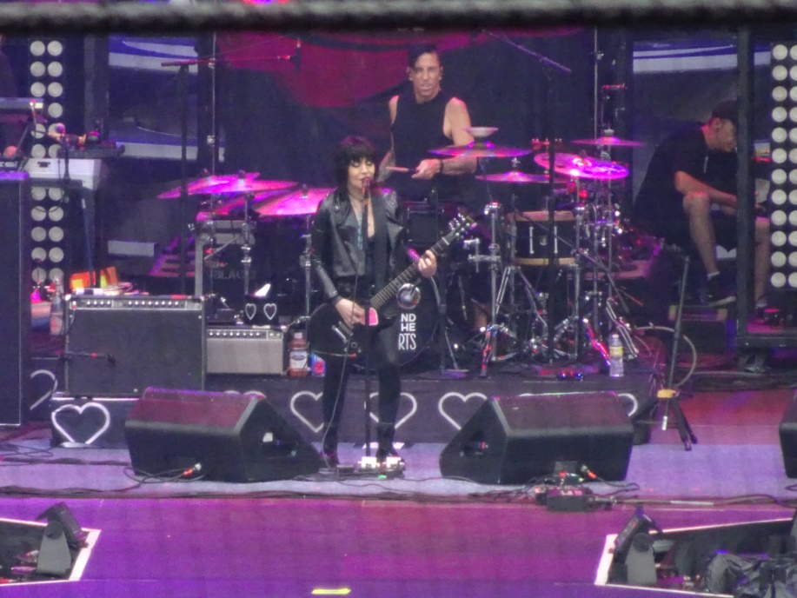
Up next were the masters of glam metal, Poison, and from the first note of their set it was obvious how badly these guys had wanted to get back playing in front of a live audience and did everything they could to show how much fun they were having on stage performing for us. It was my second time seeing Poison and as soon as the band started everyone was up in their seats and fists were in the air, horns too, as the band took us through a nine song set. The stands were I would say near 90% full by now and every song was a crowd favorite. The band’s acoustics were spot on which is hard to do in such a large stadium, they really sounded near crystal clear. Lead guitarist C.C. DeVille played a touching tribute of ‘Eruption’ and pointed to the heavens for Eddie Van Halen, and think every phone in the stadium was in the air when they played ‘Every Rose Has it’s Thorn’, their monster ballad that has lived in in all of its glory and agony all of these years.

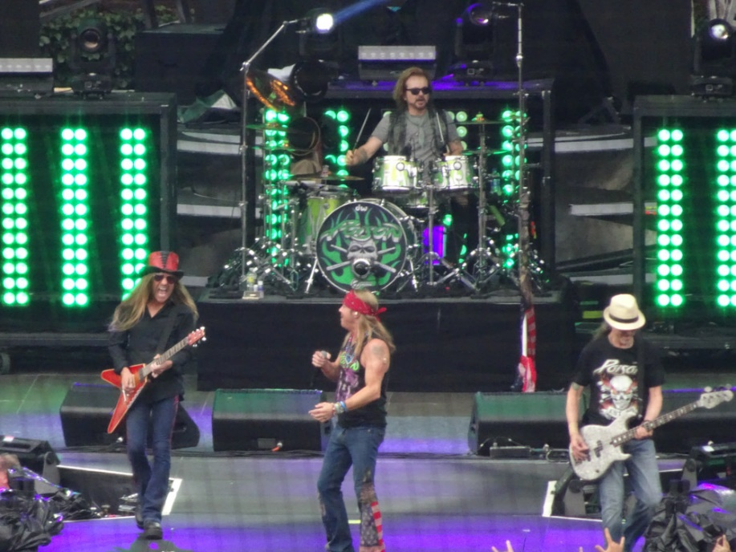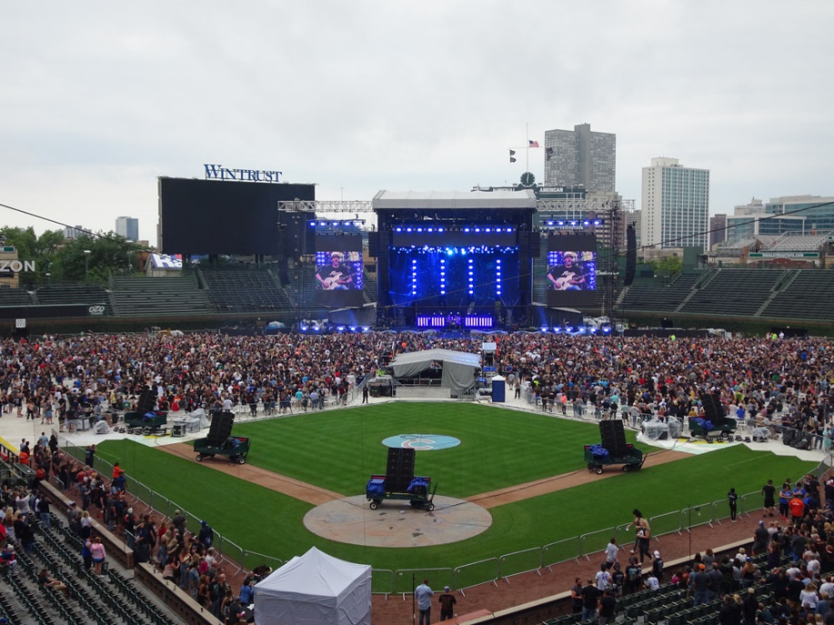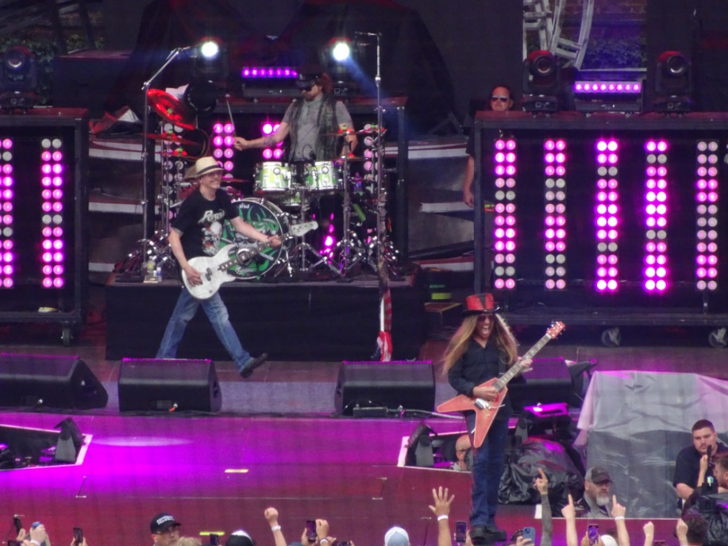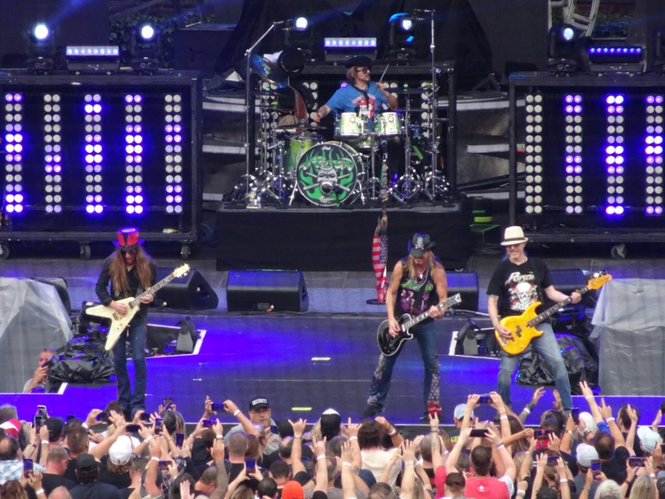
After a brief intermission, smoke machines near the stage and arranged around the baseball infield fired up this massive cloud just as news alerts flashed on the screens to announce the entry of the true bad boys of makeup and hair driven heavy metal. As Mötley Crüe hit the stage we were still obscured from that insane amount of smoke they poured in, but the sound was unmistakable that we had entered the ‘Wild Side’ to start off. Next up was an immediate walk down memory lane for me as the band blasted out ‘Shout at the Devil’ I went back in time to my second ever concert – seeing the Shout at the Devil tour in Tampa in 1984. This band and I have some history as this was my sixth time seeing them.
While I am a huge fan of the band and they freaking sound as tight as ever, in my opinion lead singer Vince Neil has always struggled live when I have seen them and that is not a knock, but just something I have come to expect is all. And Mick Mars, the guy in such excruciating pain from his long time back issues, at age 71 is still out there just slaying on his guitar – I saw so many people playing air guitar to his solos. Every song of their fifteen song set list (which included a pretty kick ass medley as their discography has too many songs to try and fit into one show, so the medley was perfect, playing arts of ‘Smokin’ in the Boys Room’, ‘Helter Skelter’ and their cover of the Sex Pistols ‘Anarchy in the U.K.’). The band sort of relies on a huge laser, smoke and light production but they don’t really need it. Scantily clad ladies dancing and singing backup vocals complete the visual spectacle on stage, but I think the show would kick just as much ass if they just went out there and rocked.

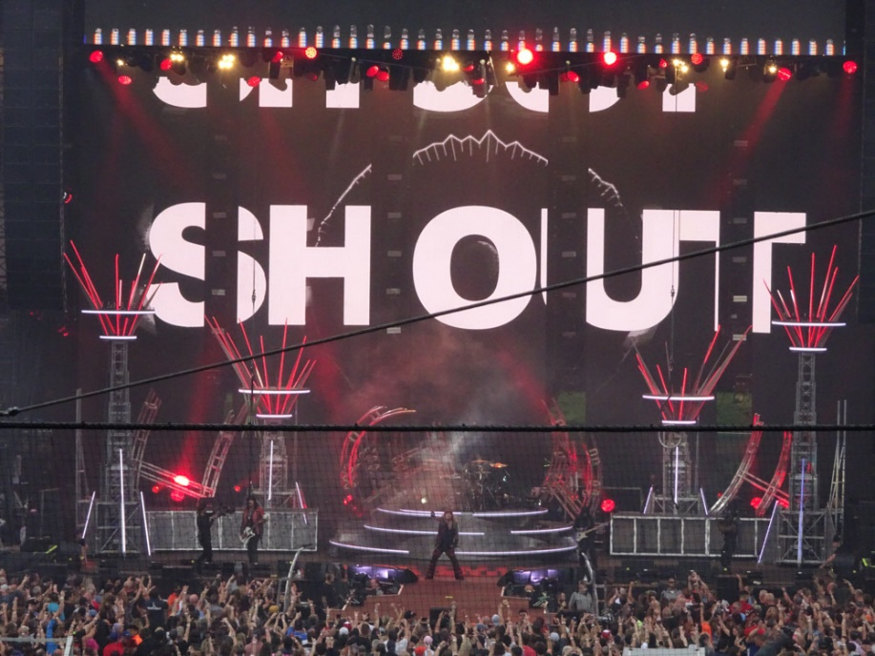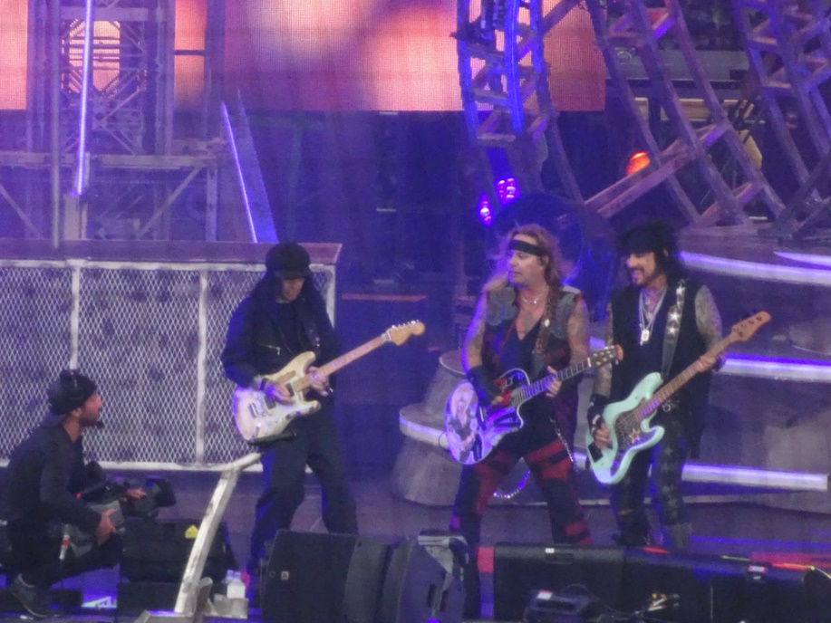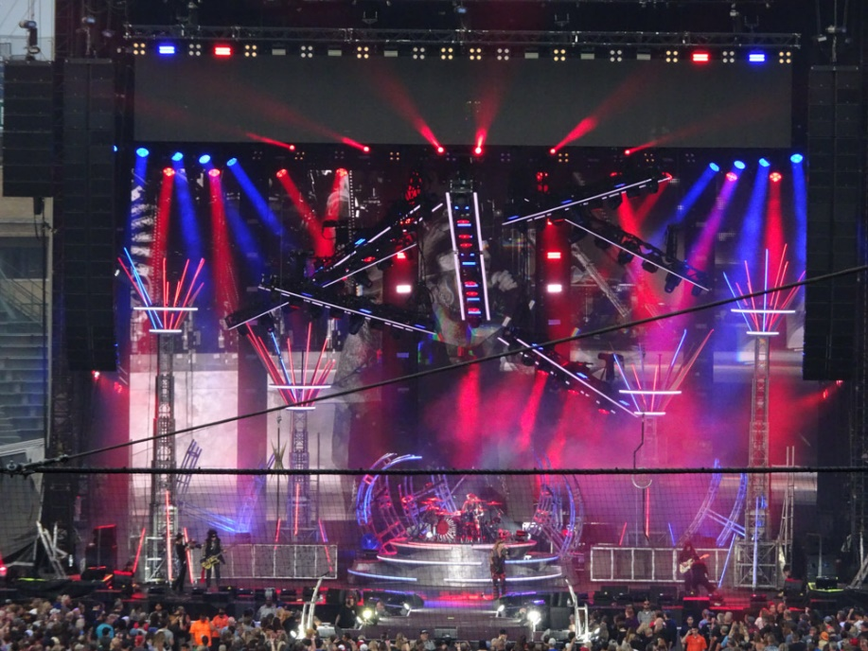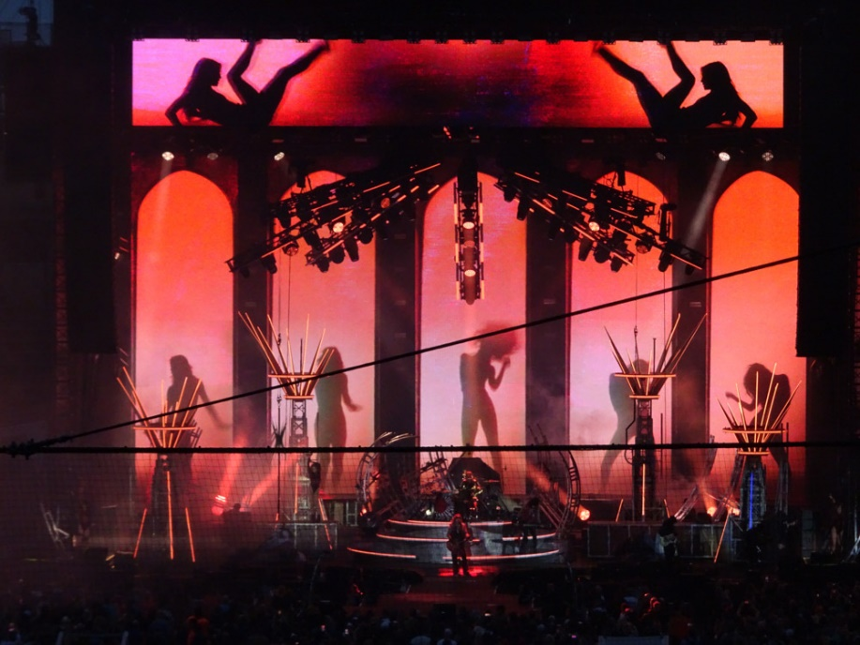
With only Def Leppard left to play this evening, as the time grew closer a ten minute countdown began to display on the stage screens and in unison I think everyone in that stadium counted the seconds down till these British rockers tore into and started with two songs in a row off of their just released CD. I mentioned to the Maiden how bold of a move it is/was to start off their set with not just one, but two songs from the new album. While everyone was on their feet the moment that countdown hit zero and the music restarted, it was apparent not everyone was familiar with the newer material. Not like their monster hits which once they came along in the set you would have thought the crowd was singing louder than the production set up if that is even possible.
This was my third time seeing the band and they never have disappointed live. I had read that for the nights when Def Leppard was the final act (the two headliners alternate closing the show each stop on the tour) that there was a mini exodus of people leaving after Mötley Crüe but that was not in evidence this evening. Plugged in rock gave way to a three song acoustic portion of their eighteen song set. Def Leppard opted not for the massive smoke and lasers, relying instead on letting their music do the talking with a very simple stage layout and as with the other bands I do not think there was a single person in their seat. The band sounded great and the Maiden and I were not alone in singing along with their anthemic hits.

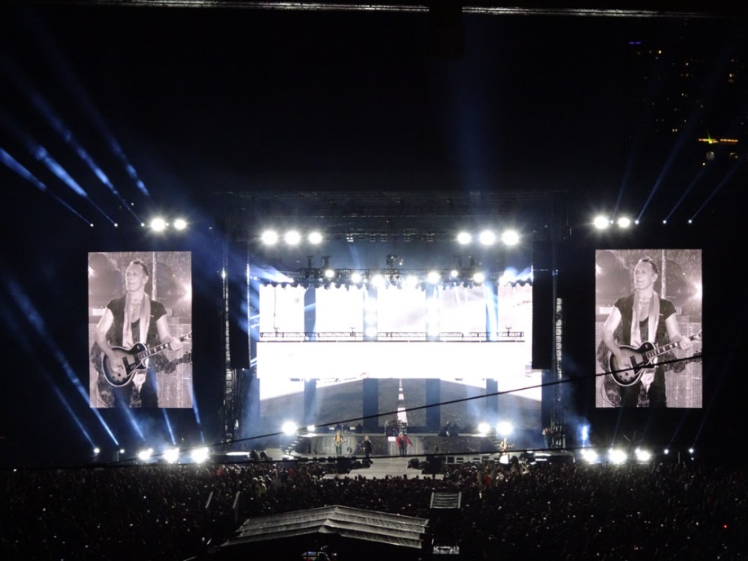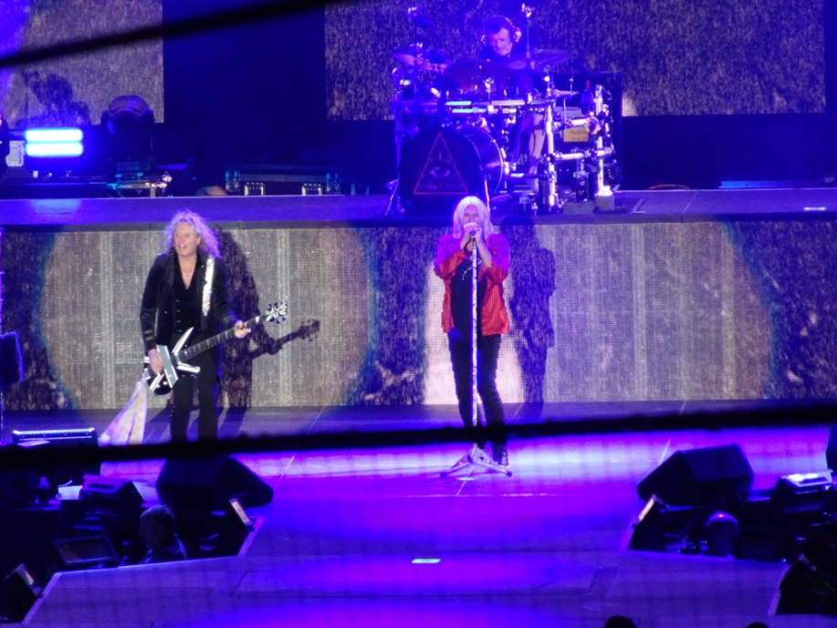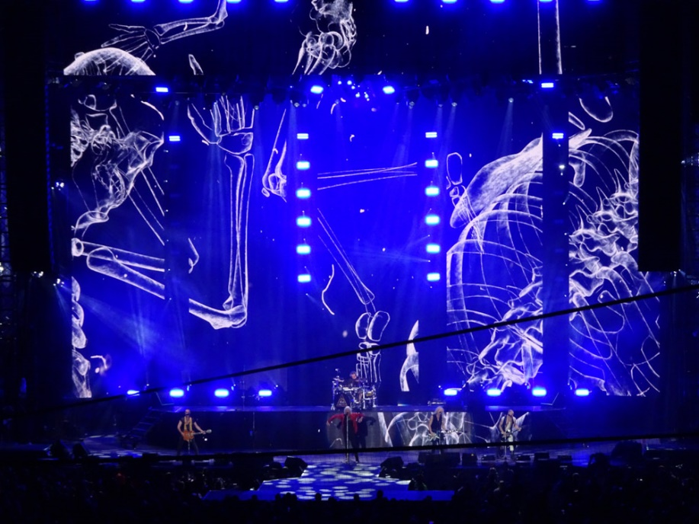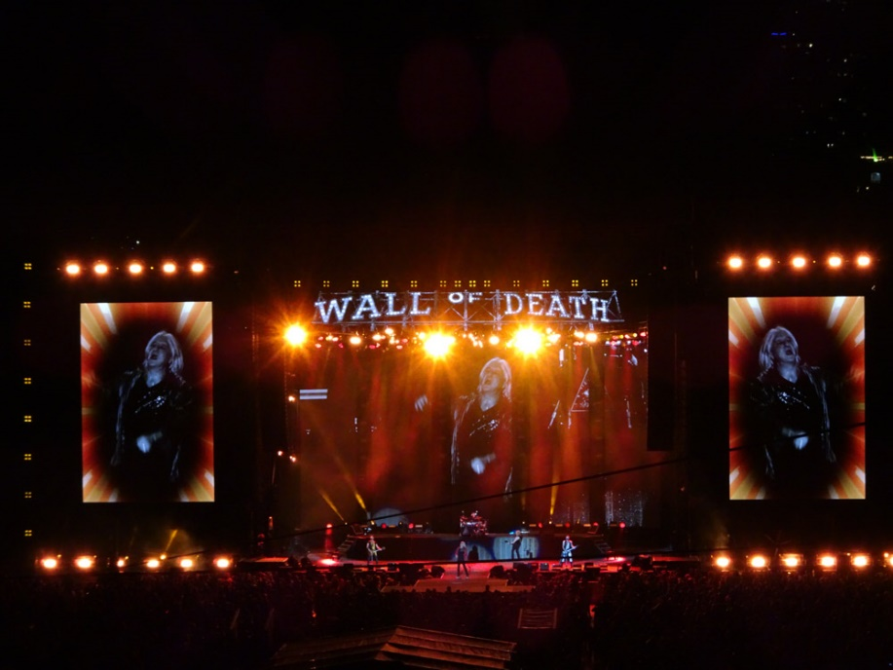
In conclusion, it was a stellar night of some rock-n-roll that is very close to my heart. These are the bands that I grew up listening to and following (hence mentioning my first musical purchase and second concert). While the peeps around us, the Maiden herself, and several of my friends who have seen earlier stops on this tour had the consensus that Poison stole the show, my favorite was seeing Mötley Crüe. Sure, their piped in smoke obscured the stage more than once, but their early releases are so ingrained in my musical roots that they are certainly near the top of my all-time favorite bands. I can say that every band this evening totally kicked ass and this concert is easily among my favorites I have ever seen. Do not hesitate if you are on the fence to see this show. If there is still a date scheduled near you I am certain you will have an incredible experience seeing this rock history laden tour!

