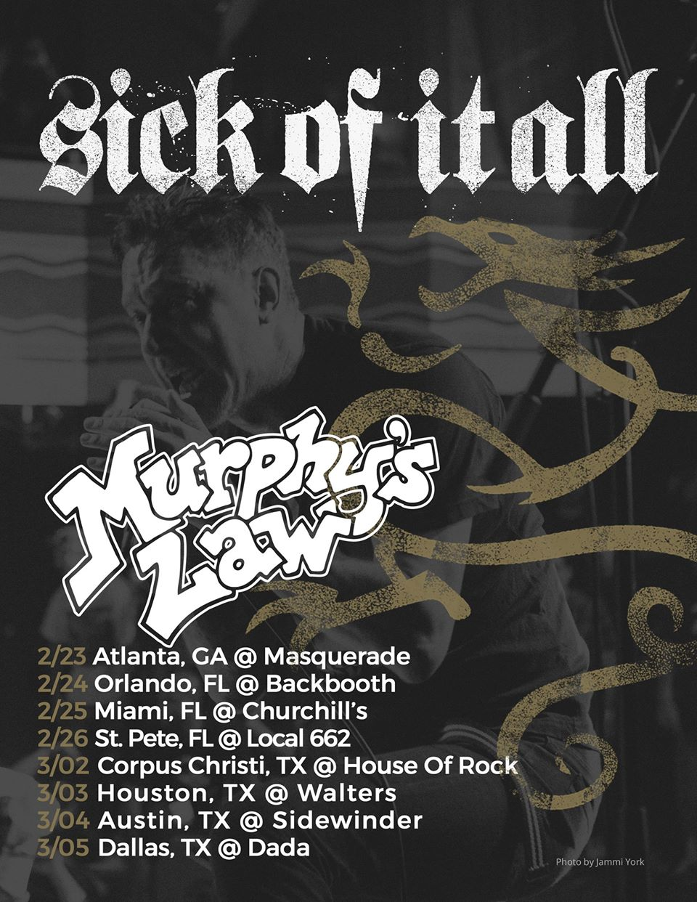

Legendary hardcore punk bands Sick of it All and Murphy's Law invade Florida for a pair of local shows, playing Orlando’s Backbooth on Friday February 24th and the Local 662 in St. Petersburg, Sunday, the 26th. Both bands formed as part of the New York hardcore punk scene over thirty years ago and have a cult like dedicated following. Also with both bands having been the influence of countless other bands and musicians over the decades these shows are likely to sell out so be sure to make sure to get your tickets ahead of time.
Murphy’s Law combines elements of thrash, punk, hardcore, reggae and humor resulting in a fun party style type music where if you are feeling down or having a bad day just listen to a couple of their songs and you will find yourself in a better mood. Sick of it All tends to stay hard, fast and aggressive, with high energy similar to a Slayer show where the mosh pit never stops for the entire set, this band is the poster child for the harder sounds of New York hardcore movement.

SICK OF IT ALL - Road Less Traveled (OFFICIAL VIDEO)
Murphy's Law - What Will The Neighbors Think?

Sick of it All, Murphy's Law & more Friday, February 24th
Backbooth, Orlando - $18
Tickets available here
Sick of it All, Murphy's Law & more Sunday, February 26th
Local 662, St. Petersburg - $18
Tickets available here

Avoid Ticketmaster fees and pick up tickets at Daddy Kool Records
666 Central Avenue North, St. Petersburg, FL 33701
map
**********delete this – is there a local record shop in the Orlando area to pick up tix without the ticketmaster fees? (Daddy Kool only charges like $2, much less than TM) – if so please add it in and let me know for future writings***********

