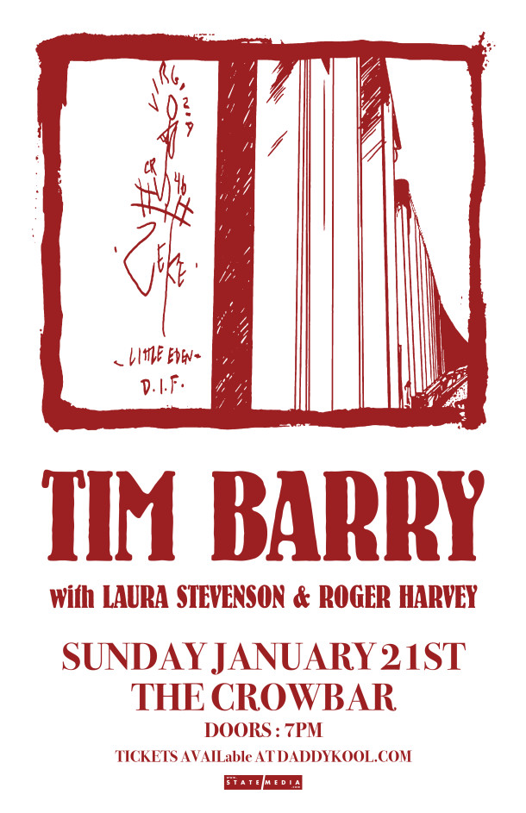

Transformed from his days as the lead singer for a punk rock band, Tim Barry brings his folk musical style to Crowbar in Tampa on January, 21, 2018 along with special guests Laura Stevenson and Roger Harvey.
Tim Barry "Solid Gone"
Tim Barry "Walk 500 Miles"
Laura Stevenson - Jellyfish
Roger Harvey - City Deer
Tim Barry with special guests Laura Stevenson and Roger Harvey
Crowbar – Ybor City, Tampa, FL - January 21, 2018 - $13
Tickets available here
Avoid Ticketmaster fees and pick up tickets at Daddy Kool Records
666 Central Avenue North, St. Petersburg, FL 33701
map

