Ugly Kid Joe - ‘Rad Wings of Destiny’ tour
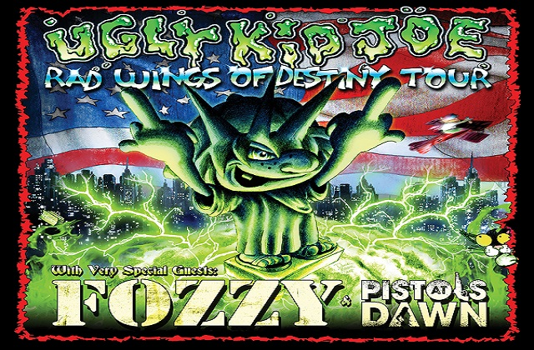
Prepare for a walk backwards in time as America’s least wanted band is hitting the road. Supporting a new release in 2022, hard rockers Ugly Kid Joe will bring their ‘Rad Wings of Destiny’ tour to Florida with three stops in consecutive days in early June. This is the band’s first U.S. tour in 27 years and when this tour was announced in mid-January earlier this year I had a couple of friends who reached out to me saying that we HAD! TO! GO! I do not recall which one of our group of friends was the first to get the debut Ugly Kid Joe release, ‘America's Least Wanted’, but I remember it being a staple in our music rotation. Ugly Kid Joe's musical style can be described as a blend of hard rock, heavy metal, and alternative rock, with a heavy guitar-driven sound, easily sing along melodies, and lyrical humor. Even the band’s name is a spoof on the band Pretty Boy Floyd.
‘Rad Wings of Destiny’ is the band’s first release in seven years and only their second since 1996. With a setlist that will span almost all of the band’s discography, including of course their popular tracks, a couple of deep cut surprises and their famous Harry Chapin cover of Cat's in the Cradle. Support on this tour will come from the band Fozzy, led by singer and professional wrestler Chris Jericho, and the band Pistols At Dawn. With tens of millions of views on YouTube and now eight studio albums, the band Fozzy have certainly established a foothold in the rock and metal community and I am looking forward to experiencing a new band I am not familiar with, Pistols At Dawn, opening the show and setting the tone for a night of kick ass rock and roll.
The Florida dates for Ugly Kid Joe, Fozzy and Pistols At Dawn:
Saturday, June 03 - The Ranch, Fort Myers, FL
Sunday, June 04 - Jannus Live, St. Petersburg, FL
Monday, June 05 - Club LA, Destin, FL

Ugly Kid Joe - Everything About You (official video)
Ugly Kid Joe - GodDamn Devil (uncensored)
Fozzy - Judas (official video)
Fozzy - Painless (official video)
Pistols At Dawn - Under The Surface (official video)
To purchase tickets for the Florida shows:
Tickets for The Ranch
Tickets for Jannus Live
Tickets for Club LA