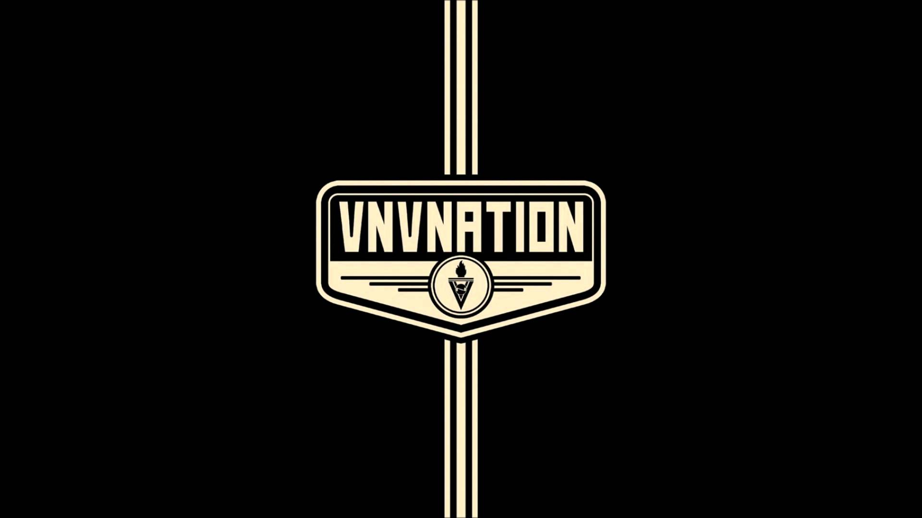

If I had to pick my favorite outdoor venue in the Tampa/St. Pete area it would without a doubt be Jannus Live and VNV Nation brings their blend of synthpop, trance and electronic body music (EBM) to this fantastic venue on Friday, October 28th. Fans of this electronic duo will want to be in attendance as this show is one of only twelve unique and exclusive ‘Gala Events’ celebrating their full discography spanning the last twenty years. The concert is billed as a three hour show with surprise guest performances here and there (throughout the tour), specials, rarities, different setlists, and at most of the shows there will be a meet and greet after the concert. VNV Nation fans are in for a treat with a unique performance at this excellent venue.

VNV Nation - Further
VNV Nation-Chrome
VNV Nation - Illusion
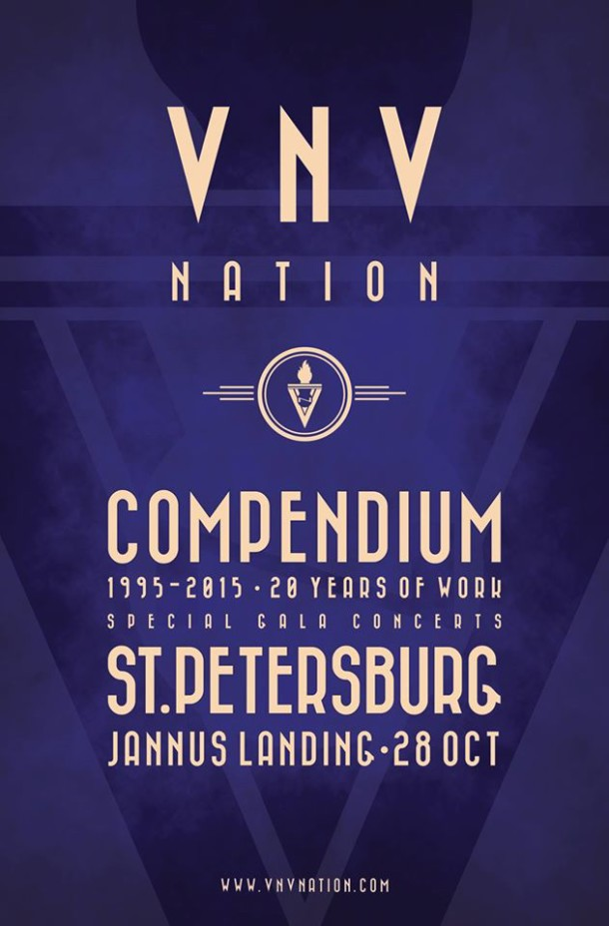
VNV Nation 2016 exclusive Gala Events:
07 Oct 16 | USA | Seattle | Showbox |  | [ tickets ]
09 Oct 16 | USA | San Francisco | The Regency |  | [ tickets ]
12 Oct 16 | Canada | Calgary | Flames Central |  | [ tickets ]
14 Oct 16 | USA | Los Angeles | The Belasco Theater |  | [ tickets ]
18 Oct 16 | USA | Denver | The Bluebird Theater (setlist #1) |  | [ tickets ]
19 Oct 16 | USA | Denver | The Bluebird Theater (setlist #2) |  | [ tickets ]
21 Oct 16 | USA | Dallas | Gas Monkey |  | [ tickets ]
23 Oct 16 | USA | Chicago | Metro |  | [ tickets ]
25 Oct 16 | Canada | Toronto | The Danforth |  | [ tickets ]
26 Oct 16 | Canada | Montreal | Corona Theater |  | [ tickets ]
28 Oct 16 | USA | St-Petersburg | Jannus Landing |  | [ tickets ]
29 Oct 16 | USA | New York | Playstation Theater

