Randy Cook
Chief Metal Officer, Photographer
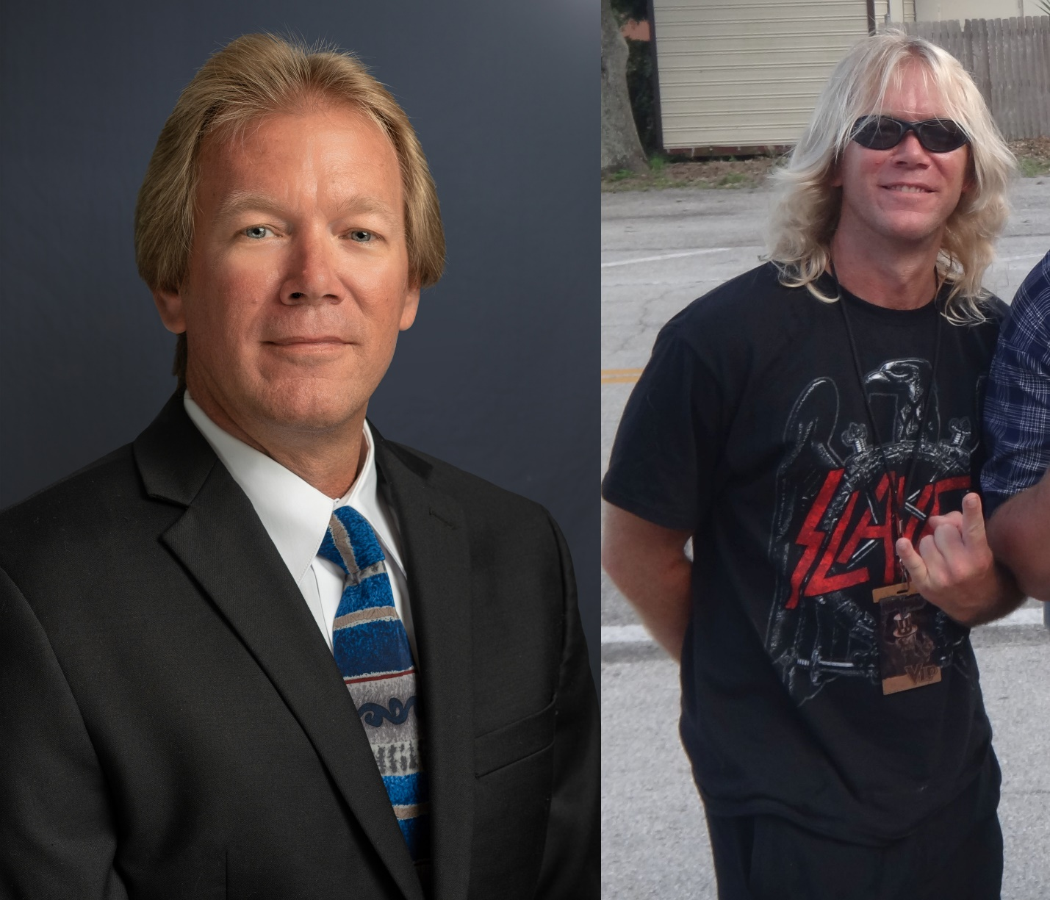
Music speaks to us all in our own way and while I cannot say that I was born a metalhead from day 1, being a teenager in the late 1980’s with all of the timeless metal releases sure had an effect on my musical tastes for decades. I can pinpoint the day when I was introduced to the music of Metallica and how that day began my formative metalhead journey. I have broadened my musical spectrum over the years but take almost any 80’s glam, hair or thrash metal song and I can name that tune in 2 notes.
A St. Petersburg, Florida native I have never lived outside of the paradise that is Pinellas County. I graduated from St. Petersburg College with a Bachelor’s degree in Technology Management and hold 3 Microsoft certifications. By day I have worked in the IT field since 1999. Currently I play with servers and mountains of data as a systems administrator for an investment management firm where over the years I have honed my Microsoft Excel skills to achieve Jedi Master Level!
For me there is nothing that compares to the excitement of going to live shows. I have been fortunate to have seen and photograph many bands, and to have met some incredible life-long friends along the way. The Show History page on my website is a great representation of what happens when you cross a statistics loving metalhead with an IT nerd. I wish I would have kept track of all the shows I saw back in the day before I became the Excel Jedi I am today - many shows were pay at the door or if a friend bought the tix, I didn't think to keep the stub. Back then I had no idea I was a future Chief Metal Officer in training.
I also attest that each show has its own story - who went, how drunk we were (back in the day at least), how freaking awesome the show was, and then as the years went on did we see that one crusty older burnout dude we seem to see at every concert (and still do!)? Or is he there looking for us? I have a great story of how accidently winning tickets for and going to a k.d. lang concert turned out to be a metal experience. \m/
Let’s talk about music, metal and concerts - randy@hornsraised.com

Randy
CMO \m/

